Belt and Road Reboot: Beijing’s Bid to

De-Risk Its Global Infrastructure Initiative

# Chapter 3: Redesigning the Belt and Road for Safety and Speed

November 2023

Bradley C. Parks, Ammar A. Malik, Brooke Escobar, Sheng Zhang, Rory Fedorochko, Kyra Solomon, Fei Wang, Lydia Vlasto, Katherine Walsh, and Seth Goodman



# Chapter 3: Redesigning the Belt and Road for Safety and Speed

### Section 1: Beijing’s journey from skeptic to advocate of ESG risk management

For the better part of the last two decades, Beijing sought to position itself as an alternative source of infrastructure ﬁnancing for governments that would prefer not to deal with OECD-DAC donors or multilateral development banks. It characterized itself as a demand-driven ﬁnancier of South-South cooperation and tacitly encouraged its foreign counterparts to bypass the rules and standards of OECD-DAC donors and multilateral development banks by fast-tracking large-scale infrastructure projects with as little “red tape” and “hassle factor” as possible. It offered fast and ﬂexible project preparation procedures; a streamlined set of loan and grant approval processes; the ability to issue contracts without competitive bidding requirements; and less stringent environmental, social, and governance (ESG) safeguards.[216]

China’s value proposition was compelling. Between 2000 and 2021, 140 LICs and MICs accepted $825 billion of aid and credit from Beijing for 4,800 infrastructure projects.[217] China became the developing world’s go-to banker for big-ticket infrastructure projects because it demonstrated three comparative advantages vis-à-vis OECD-DAC donors and multilateral development banks (MDBs): scale, speed, and impact. Beijing bankrolled large-scale infrastructure projects that its peers and competitors were unwilling or unable to support.[218] It ﬁnanced 1,385 infrastructure projects with grants and loans worth $100 million or more between 2000 and 2021.[219] China also earned a reputation for implementing brick-and-mortar projects with lightning speed: the average Chinese government-ﬁnanced infrastructure project between 2000-2021 took only 2.7 years to complete.[220] Similar projects ﬁnanced by the World Bank and regional development banks usually took 5-10 years to complete (Bulman et al. 2017; Lagarda et al. 2018; Duggan et al. 2020; World Bank 2023c). China’s overseas development projects—in particular, those involving the construction of infrastructure such as roads, bridges, tunnels, railways, and ports—also generated signiﬁcant economic beneﬁts in a politically relevant timeframe.[221] In an evaluation of 4,304 projects in 138 LICs and MICs over a 15-year period, Dreher et al. (2021) ﬁnd that the average project increased economic growth by

0.95 percentage points two years after securing funding approval from Beijing.[2][2][2] Bluhm et al. (2020) provide evidence that China’s connective infrastructure project portfolio was especially effective at promoting spatially-inclusive economic development—by decentralizing economic activity within the provinces and districts where they were implemented.[223]

Beijing’s track record of bankrolling and building big-ticket infrastructure projects with record speed and near-term economic impact changed the nature of policymaker demand in the Global South. Through its *Listening to Leaders* program, AidData has repeatedly surveyed thousands of senior and mid-level governmental ofﬁcials across 140 LICs and MICs, and these leaders now report a strong preference for working with Beijing rather than its competitors on infrastructure projects (Custer et al. 2021; Horigoshi et al. 2022; Blair et al.

2022b).

Still, the fact that China—seemingly overnight—became the Global South’s infrastructure ﬁnancier of ﬁrst resort is remarkable. Large-scale infrastructure projects are notoriously difﬁcult to implement. They often encounter major delays and cost overruns and raise concerns about pollution, biodiversity loss, the displacement of nearby residents, and the preservation of cultural heritage.[224] If they are not carefully designed and implemented, they can also lead to public protests, lawsuits, labor strikes, corruption scandals, and allegations of political favoritism.[225]

Beijing initially sought to overcome these challenges by asking political leaders, rather than technocrats, to propose infrastructure projects and oversee their implementation (Dreher et al. 2019, 2022).[226] It relied on presidents and prime ministers and their deputies to resolve complex and contentious matters that could delay or derail projects—for example, the grievances and compensation demands of those displaced or harmed by construction activities (Dreher et al. 2022). It also dispensed with many of the costly and cumbersome requirements of Western donors and multilateral development banks (MDBs). Rather than insisting upon strict adherence to international ESG safeguards (such as those described in the IFC’s Performance Standards on Environmental and Social Sustainability), Beijing’s state-owned banks requested compliance with national rules and standards (Export-Import Bank of China 2017; Chen and Landry 2018; Baehr et al. forthcoming). To facilitate rapid mobilization as soon as loan or grant applications were approved, they issued no-bid contracts to Chinese companies with an established, on-the-ground presence (Bräutigam 2019).[227] The absence of any requirement or expectation to coordinate with other donors and lenders eliminated additional obstacles to implementation (Bourguignon and Platteau 2015; Furukawa 2018).

But speed and convenience came at a cost: at least 54% of China’s overseas infrastructure project portfolio from 2000 to 2017 had signiﬁcant environmental, social, or governance risk exposure (see Figure A38 in the Appendix).[228] In some cases, multi-billion dollar public investment projects were suspended or rescoped because of insufﬁcient inattention to environmental and social impact assessments (see Lu et al. 2023b and Box 3b). In other cases, journalists and civil society organizations uncovered evidence of Chinese companies and host government ofﬁcials colluding by artiﬁcially inﬂating sole-source contract prices for construction projects and sharing the illicit proceeds (Malik et al. 2021: 67; Dreher et al. 2022: 11-12). In still other cases, local grievances were not addressed in a timely or thorough manner and they metastasized into reputational liabilities (that we analyze at greater length in Chapter 4).[229]

By the end of the early BRI era, the authorities in Beijing seemed to coalesce around the idea that sustaining elite and public support for its ﬂagship global infrastructure initiative would require more effective ESG risk management and mitigation. One of the ﬁrst signs that change was afoot came in November 2017 when the China Banking Regulatory Commission (CBRC)—the country's top banking regulator—issued a new set of rules, requiring CDB and China Eximbank to put in place more robust environmental and social risk management procedures (CBRC 2017a, 2017b).[230] By 2018, the authorities were planning a transition “from a hazily deﬁned BRI 1.0 to a more ﬁne-tuned BRI 2.0” (Ang 2019). On August 27, 2018, in the run-up to the ﬁfth anniversary of the BRI, Xi Jinping used a Chinese painting metaphor to call for “a switch from xieyi, freehand painting for outlining broad strokes, to gongbi, the careful inscription of details” (Ang 2019). Then, in April 2019, he gave a speech at the Second Belt and Road Forum for International Cooperation where he announced that China would “adopt widely accepted rules and standards and encourage participating companies to follow general international rules and standards in project development, operation, procurement and tendering and bidding” (Ministry of Foreign Affairs of the People's Republic of China 2019). He conveyed during the same speech that “in pursuing Belt and Road cooperation, everything should be done in a transparent way, and we should have zero tolerance for corruption” (Ministry of Foreign Affairs of the People's Republic of China 2019).[231]

One year later, Beijing signaled preliminary interest in “multilateralizing” the BRI by co-ﬁnancing, co-designing, and co-implementing infrastructure projects with Western and multilateral development ﬁnance institutions and subjecting these projects to stronger safeguards.[232] It teamed up with eight multilateral institutions—the World Bank, the Inter-American Development Bank, the Asian Development Bank, the European Bank for Reconstruction and Development, the European Investment Bank, the International Fund for Agricultural Development (IFAD), Corporación Andina de Fomento, and the Asian Infrastructure Investment Bank—to establish a Multilateral Cooperation Center for Development Finance (MCDF).[233] The Center’s mandate is to (a) invest in more upstream project preparation work; (b) build the capacity of lenders and borrowers to more effectively manage and mitigate risks related to debt sustainability, procurement, corruption, and environmental and social issues; and (c) facilitate greater information-sharing and coordination between Chinese and non-Chinese development ﬁnance institutions (AIIB 2021).[2][3][4]

Then, in 2021, SAFE—the ultimate source of funding for most of China’s state-owned policy banks, commercial banks, and investment funds (see Box 2b in Chapter 2)—announced that it would prioritize “adopting MDB’s ESG criteria” and “incorporating ESG principles into the whole project investment process from decision-making to post-investment management” (SAFE 2021: 54).[235] In parallel, through a multilateral forum known as the International Platform on Sustainable Finance (IPSF), the EU and China launched a joint effort to assess the commonalities and differences in their respective taxonomies for environmentally sustainable investments (Moody's Investor Service 2022; IPSF 2022; HKGFA and Guangdong Green Finance Committee 2022).[236] This collaboration resulted in the 2021 publication of a so-called Common Ground Taxonomy (CGT), which in turn was “incorporated into domestic regulation [in China]” and “directly used by Chinese banks as standards for issuing green bonds in the international market” (Cheng and Zhang 2023: 10).

All of these actions and rhetorical commitments suggest that Beijing has some level of interest in more effectively managing the ESG risks in its overseas infrastructure project portfolio—and potentially even harmonizing its policies and practices with prevailing international development ﬁnance rules and standards. However, interest does not necessarily translate into implementation, so our aim in this chapter is to determine if China has learned from past mistakes and recalibrated the ways that it ﬁnances, designs, and implements infrastructure projects in the Global South.[237] More speciﬁcally, we will use the

3.0 version of AidData’s GCDF dataset to (a) document the scope and severity of the ESG risks in China’s overseas infrastructure project portfolio; (b) identify whether, when, and how it has sought to mitigate these project implementation risks; and (c) determine whether its infrastructure projects with and without strong ESG safeguards have fared differently during implementation.

Our ﬁndings demonstrate that, although the ESG risk proﬁle of China’s overseas infrastructure project portfolio deteriorated during the pre-BRI period and early BRI period, there are signs of improvement during the late BRI (“BRI 2.0”) period. Chinese lenders and donors have responded to rising levels of ESG risk by putting in place increasingly stringent safeguards that may ultimately undermine G7 and MDB efforts to outcompete Beijing on “quality” and “safety” grounds. Chinese grant- and loan-ﬁnanced infrastructure projects that are subjected to strong ESG safeguards present fewer environmental, social, and governance risks during implementation. They are also less likely to be suspended or canceled. Perhaps most importantly, Chinese grant- and loan-ﬁnanced infrastructure projects that are subjected to strong ESG safeguards do not face substantially longer implementation delays than those subjected to weak ESG safeguards. Our ﬁndings therefore suggest Beijing enjoys a stronger position in the global infrastructure ﬁnancing market than its bilateral and multilateral competitors realize. Developing countries have made their preferences very clear: they want to work with lenders and donors that are willing and able to quickly design and implement big-ticket, high-impact infrastructure projects without unreasonably high levels of ESG risk.[238] Beijing is taking active measures to meet this challenge. Whether its competitors will do the same is an open question.

### Section 2: Measuring the scope and severity of ESG risk exposure in China's infrastructure project portfolio

We begin by measuring the nature and extent of ESG risk exposure in China’s overseas infrastructure project portfolio—and how it has changed over time.[239] We do so in ﬁve ways. First, we identify whether China is locating large-scale infrastructure projects in environmentally sensitive areas. Second, we analyze whether China is placing such projects in socially sensitive areas—speciﬁcally, in areas where indigenous populations are often denied free, prior, and informed consent (FPIC). Third, we assess whether China is locating large-scale infrastructure projects in geographical areas that are vulnerable to political capture and manipulation by governing elites in host countries. Fourth, we evaluate the extent to which China is relying on contractors sanctioned for fraudulent and corrupt behavior for the implementation of its overseas infrastructure projects. Fifth, based upon narrative evidence from the 3.0 version of AidData’s GCDF dataset, we ﬂag all infrastructure projects for which it is known that a signiﬁcant environmental, social, or governance challenge arose before, during, or after implementation.

Figure A39 presents the cumulative number of Chinese grant- and loan-ﬁnanced infrastructure projects located in environmentally sensitive areas within LICs and MICs between 2000 and 2021. We determine if a given infrastructure project is located in one or more environmentally sensitive areas by ﬁrst merging precisely geocoded data on Chinese ODA- and OOF-ﬁnanced infrastructure project sites with two separate datasets: (1) the boundaries of designated terrestrial and marine protected areas from the World Database on Protected Areas (WDPA), which we convert into a 1 km x 1 km grid cell raster; and (2) the 1 km x 1 km grid cell raster of terrestrial and marine critical habitats (as deﬁned by the

International Finance Corporation’s Performance Standard 6).[240] We then identify the subset of projects with one or more sites that overlap with a terrestrial protected area, a marine protected area, a terrestrial critical habitat, and/or a marine critical habitat.[241] In total, we ﬁnd 1,035 infrastructure projects in 108 countries supported by grants and loans from China worth $233 billion that are located in environmentally sensitive areas.[242]

Figure A40 presents the cumulative number of Chinese grant- and loan-ﬁnanced infrastructure projects located in socially sensitive areas within LICs and MICs between 2000 and 2021. We determine if a given infrastructure project is located in one or more of these areas by ﬁrst merging precisely geocoded data on Chinese ODA- and OOF-ﬁnanced infrastructure project sites with a 1 km x 1 km grid cell raster of indigenous lands.[243] We then identify the subset of projects with one or more sites that overlap with indigenous lands, which is a useful measure of social risk because infrastructure projects can cause local harm by encroaching upon the traditional territories of indigenous communities without free, prior, and informed consent (FPIC).[244] In total, we ﬁnd 547 infrastructure projects in 53 countries supported by grants and loans from China worth $112 billion that are located in socially sensitive areas.[245]

Figure A41 presents the cumulative number of Chinese grant- and loan-ﬁnanced infrastructure projects located in geographical areas within LICs and MICs that are vulnerable to political capture and manipulation between 2000 and 2021.

We determine if a given infrastructure project is located in one or more of these areas by ﬁrst merging precisely geocoded data on Chinese ODA- and

OOF-ﬁnanced infrastructure project sites with the Political Leaders’ Afﬁliation Database (PLAD), which identiﬁes the home (birth) districts (ADM2s) of political leaders in LICs and MICs.[246] Previous research has shown that Chinese aid and credit is disproportionately allocated to the home provinces and districts of political leaders in host countries and that Chinese lenders and donors lack institutional safeguards to reduce the likelihood that politically motivated projects will be approved (Dreher et al. 2019, 2022; Anaxagorou et al. 2020).[247] In total, we ﬁnd 216 infrastructure projects in 69 countries supported by grants and loans from China worth $37 billion that are located in geographical areas that are vulnerable to political capture and manipulation.[248]

Figure A42 presents 2000-2021 data on the cumulative number of Chinese grant- and loan-ﬁnanced infrastructure projects that relied on contractors sanctioned by other international ﬁnanciers for fraudulent and corrupt behavior. We determine if a given infrastructure project relied on contractors sanctioned by other international ﬁnanciers for fraudulent and corrupt behavior with a three-step process. First, we compile a list of ﬁrms historically or currently debarred by the World Bank and ﬁve other multilateral development banks (MDBs)—the African Development Bank, the Asian Development Bank, the European Bank for Reconstruction and Development, the Inter-American

Development Bank, and the Asian Infrastructure Investment Bank—as well as the dates of each ﬁrm’s formal debarment period. Then, we compare the list of debarred ﬁrm names to the ﬁrm names of implementing agencies and contractors involved in the Chinese grant- and loan-ﬁnanced infrastructure projects. Finally, we identify the subset of projects that relied upon debarred ﬁrms while they were still within their debarment periods by identifying all cases in which there was calendar day overlap between the start and end dates of an organization’s debarment period and the commitment, implementation, or completion dates of the project(s) it supported. Projects that relied upon a debarred ﬁrm are identiﬁed as posing a signiﬁcant governance risk (see Section A-6 in the Appendix for more details). In total, we ﬁnd 296 infrastructure projects in 81 countries supported by grants and loans from China worth $88.8 billion that rely on such ﬁrms.

Figure A43 presents the cumulative number of Chinese grant- and loan-ﬁnanced infrastructure projects for which there is evidence that a signiﬁcant environmental, social, or governance challenge arose before, during, or after implementation. A key feature of AidData’s 3.0 dataset—that sets it apart from other publicly available Chinese development ﬁnance datasets—is the inclusion of “cradle to grave” narratives that provide detailed information about how projects were designed and implemented in practice and why they failed, faltered, or succeeded. These narratives consist of 3.48 million words (roughly the same number of words one would ﬁnd in 34 full-length books) across 20,985 project records. They capture, among other details, project design and implementation challenges related to land acquisition; preservation of cultural heritage and archaeological sites; resettlement and compensation of indigenous communities; pollution of air, water, and soil; and adherence to anti-corruption standards. To make use of this vast trove of qualitative information, we apply a set of systematic search and categorization procedures (described in Section A-7 in the Appendix) to identify the subset of infrastructure projects for which there is evidence that a signiﬁcant environmental, social, or governance challenge arose before, during, or after implementation. In total, we ﬁnd that at least 356 infrastructure projects in 131 countries supported by grants and loans from

China worth $250 billion encountered a signiﬁcant environmental, social, or governance challenge before, during, or after implementation.[249]

Finally, to gain a bird’s eye view of the scope and severity of ESG risk in China's infrastructure project portfolio in the developing world, we use all ﬁve of these measures in combination. To determine if any given Chinese grant- or loan-ﬁnanced infrastructure project presented a signiﬁcant environmental, social, or governance risk between 2000 and 2021, we identify if it was located in an area that is environmentally sensitive, socially sensitive, or vulnerable to political capture and manipulation; relied on contractors sanctioned by other international ﬁnanciers for fraudulent and corrupt behavior; and/or encountered a signiﬁcant environmental, social, or governance challenge before, during, or after implementation.[250] Across 125 LICs and MICs between 2000 and 2021, we ﬁnd that 1,693 infrastructure projects supported by grants and loans from China worth $470 billion had signiﬁcant environmental, social, or governance risk exposure (see Figure 1.13). Over the same 22-year time period, we ﬁnd that $265 billion in Chinese grant and loan commitments for 1,101 infrastructure projects had signiﬁcant environmental risk exposure, while $192 billion in Chinese grant and loan commitments for 701 infrastructure projects had signiﬁcant social risk exposure and $211 billion in Chinese grant and loan commitments for 405 infrastructure projects had signiﬁcant governance risk exposure (see Figure 3.1).[251]

**Figure 3.1**

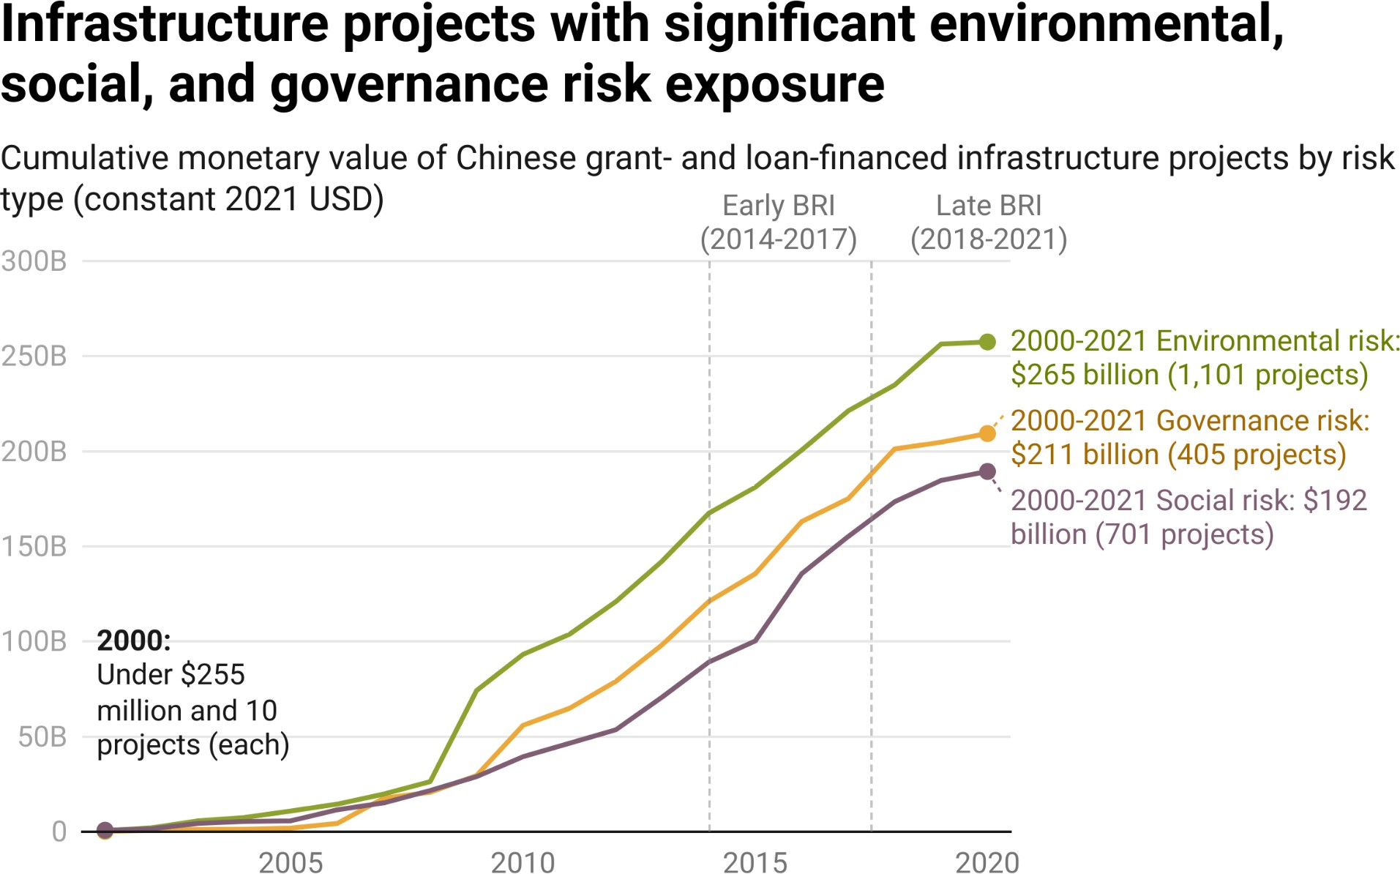

*Notes: The presence of signiﬁcant environmental, social, and governance risk (ESG) exposure is based on a project-level composite measure that is described in Section 2 of Chapter 3.*

The ESG risk prevalence rate—deﬁned as the annual percentage of China’s grant- and loan-ﬁnanced infrastructure project portfolio (measured in constant 2021 USD) with signiﬁcant environmental, social, or governance risk exposure—has ﬂuctuated over time (see Figure 3.2).[252] During the pre-BRI period, it sharply increased from 12% in 2000 to 65% in 2013. It then fell to 54% (on average) during the early BRI period and 47% (on average) during the late BRI period.[253] By 2021, it fell to 33%.

**Figure 3.2**

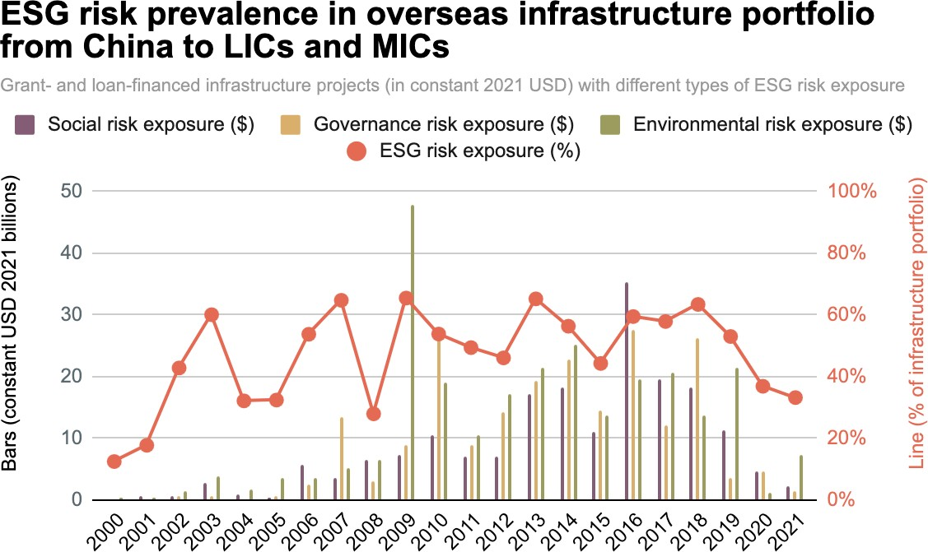

*Notes: Projects are recorded in the years when they secured ﬁnancial commitments from China, although the ESG risks that they encountered may have materialized after the ﬁnancial commitment year. The presence of signiﬁcant ESG risk exposure is based on a project-level composite measure that is described in Section 2 of Chapter 3. Likewise, environmental risk exposure, social risk exposure, and governance risk exposure are based on the project-level composite measures that are described in Section 2 of Chapter 3.*

In Figures 3.3, 3.4, and 3.5, we separately track the environmental risk prevalence rate, the social risk prevalence rate, and the governance risk prevalence rate.[254] On average, over the entire 22-year period of analysis (2000-2021), the environmental risk prevalence rate was higher (27%) than the social risk prevalence rate (20%) or the governance risk prevalence rate (18%).[255] Across these three measures, one can see a generally consistent pattern over time: risk prevalence rates mostly increased during the pre-BRI period (2000-2013) and mostly decreased during the BRI period (2014-2021). Some of the largest declines are observable during the late BRI period (2018-2021).[256] However, these declines should be interpreted with caution, as they could be the result of (a) newly approved projects not having progressed to phases of the project lifecycle when ESG risks typically materialize, (b) actual improvements in the ESG risk proﬁle of China’s overseas infrastructure project portfolio, or (c) some combination of these factors.[257]

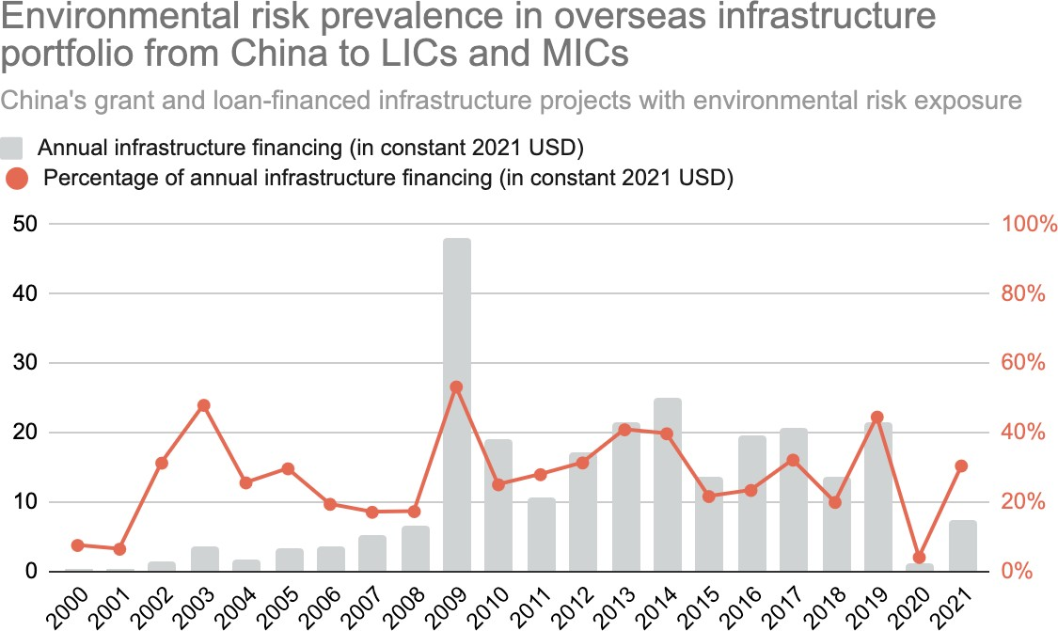

**Figure 3.3**

*Notes: Projects are recorded in the years when they secured ﬁnancial commitments from China, although the ESG risks that they encountered may have materialized after the ﬁnancial commitment year. The presence of signiﬁcant environmental risk exposure is based on a project-level composite measure that is described in Section 2 of Chapter 3.*

**Figure 3.4**

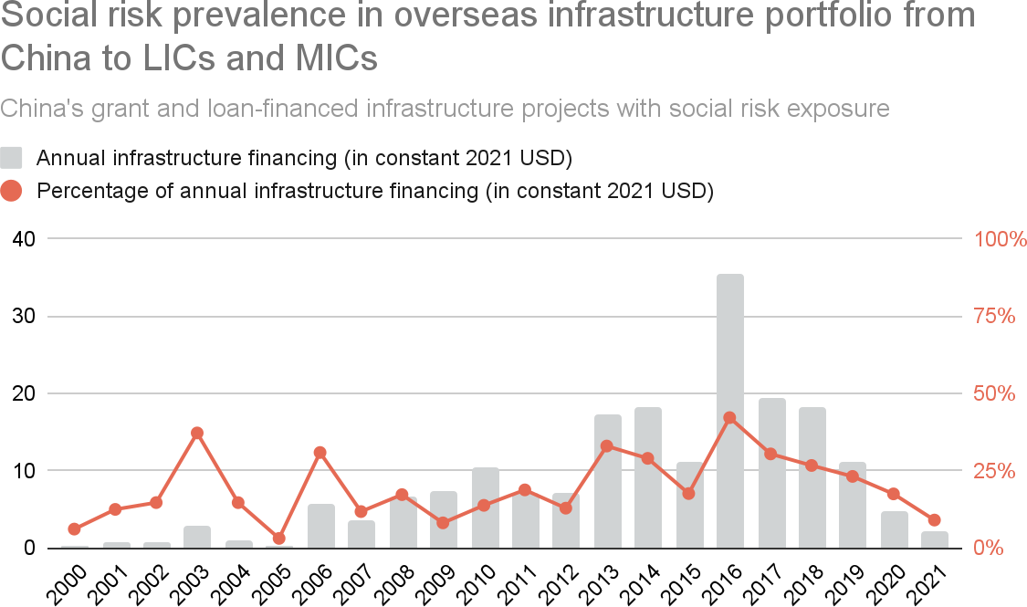

*Notes: Projects are recorded in the years when they secured ﬁnancial commitments from China, although the ESG risks that they encountered may have materialized after the ﬁnancial commitment year. The presence of signiﬁcant social risk exposure is based on a project-level composite measure that is described in Section 2 of Chapter 3.*

**Figure 3.5**

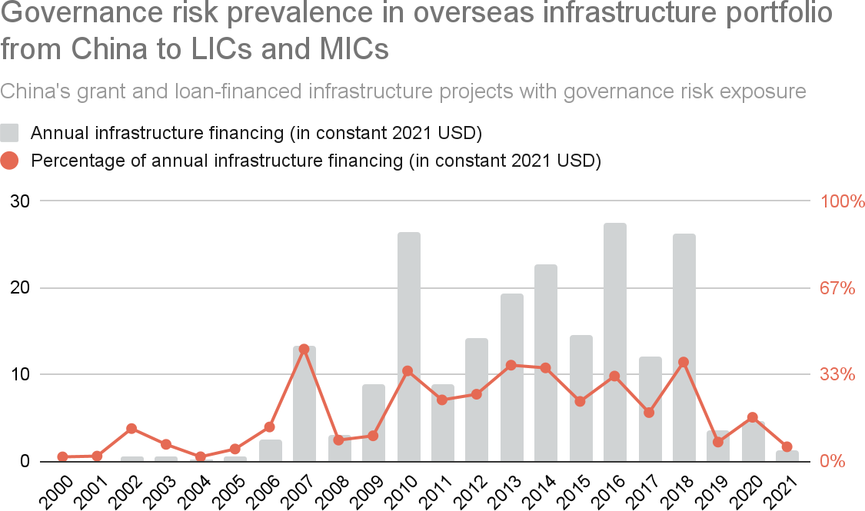

*Notes: Projects are recorded in the years when they secured ﬁnancial commitments from China, although the ESG risks that they encountered may have materialized after the ﬁnancial commitment year. The presence of signiﬁcant governance risk exposure is based on a project-level composite measure that is described in Section 2 of Chapter 3.*

Table A12 provides country-level summary statistics on the number and monetary value of Chinese grant- and loan-ﬁnanced infrastructure projects between 2000 and 2021 with signiﬁcant environmental, social, and governance risk exposure. It also provides a country-by-country breakdown of the overall ESG risk prevalence rate over the same time period. Analysis of the country-level data from Table A12 demonstrates that the ESG risk in China’s overseas infrastructure project portfolio is disproportionately concentrated in certain regions (see Table A10). For example, only 16.9% of China’s grant- and loan-ﬁnanced infrastructure project portfolio (measured in constant 2021 USD) was located in South and Central America between 2000 and 2021, but 38% of its portfolio with signiﬁcant governance risk exposure was concentrated in the same region during the same time period.[258] ESG risk in Beijing’s overseas infrastructure project portfolio is also unevenly distributed across countries with different per capita income levels (see Table A11). Governance risk is again a case in point. 37.1% of China’s grant- and loan-ﬁnanced infrastructure project portfolio (measured in constant 2021 USD) was located in upper-middle income countries (UMICs) between 2000 and 2021.[259] Yet a staggering 52.5% of its portfolio with signiﬁcant governance risk exposure was concentrated in such countries.[260] Table A12 provides evidence that a small subset of large aid and credit recipients—including Venezuela, Malaysia, and Argentina—contributed to the disproportionate concentration of governance risk exposure in UMICs.

In Figure 3.6, we identify global hotspots by fusing data on the environmental, social, and governance risk exposure of Chinese grant- and loan-ﬁnanced infrastructure projects with point, polygon, and line vector data (described in Chapter 1) that capture the geographic footprints of these projects. To do so, we ﬁrst create a 200 km x 200 km grid covering every LIC and MIC in the 3.0 version of AidData’s GCDF dataset. We then use the point, polygon, and line vector data to assign every geocoded infrastructure project to one of more of these grid cells.[261] We subsequently assign each grid cell a gradation of color—along a “heat” spectrum—based on the cumulative monetary value of Chinese grant- and loan-ﬁnanced infrastructure projects with environmental, social, or governance risk exposure in that geographical area between 2000 and

2021.[262] Whereas light pink grid cells represent areas where China has a relatively low level of risk exposure in its infrastructure project portfolio, dark purple grid cells represent areas where China has a relatively high level of risk exposure in its infrastructure project portfolio.

The map in the upper-left hand corner of Figure 3.6 demonstrates that Beijing has a particularly high level of environmental risk exposure in the Tropical Andes (including Venezuela, Ecuador, and Peru), the Southern Cone (including Argentina), East Africa (including Ethiopia, Kenya, and Uganda), West Africa (including Ghana, Togo, Benin, Nigeria, and Cameroon), Central Asia (including Kazakhstan, Kyrgyzstan, and Tajikistan), and Southeast Asia (including Laos, Cambodia, Vietnam, and Indonesia). The geographical distribution of social risk exposure, as depicted in the map in the upper-right hand corner of Figure 3.6, is broadly similar, although the hotspots are less concentrated in Central Asia and more concentrated in Ethiopia, Kenya, Pakistan, and Southeast Asia. The map in the bottom-left hand corner of Figure 3.6 also demonstrates that Beijing has a particularly high level of governance risk exposure in the Tropical Andes, East Africa, and South Asia—including Zambia, Bangladesh, and Argentina (three countries for which we provide in-depth case study evidence in Chapter 4).

Finally, in the bottom-right hand corner of Figure 3.6, we collapse all three categories of risk exposure into a single map, such that each grid cell captures the extent to which Chinese grant- and loan-ﬁnanced infrastructure projects in that area encountered signiﬁcant environmental, social, *or* government risks.

**Figure 3.6**

## A global map of China’s infrastructure project portfolio in

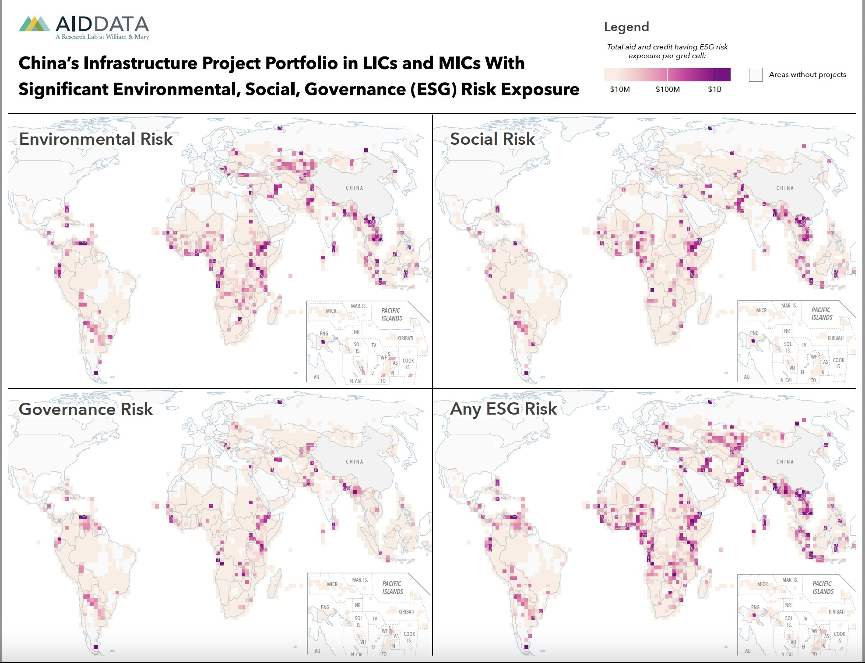**LICs and MICs with signiﬁcant environmental, social, governance (ESG) risk exposure**

*Notes: This map presents the geographical areas where China’s grant- and loan-ﬁnanced infrastructure project portfolio (measured in constant 2021 USD) has signiﬁcant environmental, social, or governance (ESG) risk exposure. Darker (purple) colors represent areas where the portfolio has high levels of risk exposure and lighter (pink) colors represent areas where the portfolio has lower levels of risk exposure. Environmental risk exposure, social risk exposure, and governance risk exposure are based on the project-level composite measures that are described in Section 2 of Chapter 3.*

### Section 3: Measuring the stringency of ESG safeguards in China’s infrastructure project portfolio with new sources of contractual evidence

Although Beijing clearly faces a wide array of ESG risks in its overseas infrastructure project portfolio, little is known about the safeguards that it has put in place to manage and mitigate these risks. Another blind spot is whether and how Chinese state-owned lenders have strengthened or weakened their ESG safeguards over time.

The 3.0 version of AidData’s GCDF dataset provides a unique opportunity to ﬁll this evidentiary gap.[263] As part of the primary source identiﬁcation work that was undertaken to support the construction of the dataset, AidData obtained a large cache of unredacted infrastructure ﬁnancing agreements via ofﬁcial sources in LICs and MICs, including government registers and gazettes, aid and debt information management systems, and parliamentary oversight institutions.

These grant and loan agreements represent “high-value sources,” in that they provide detailed information about whether ﬁnanciers, at the time that they signed the agreements with their host country counterparts, identiﬁed behavioral expectations related to ESG risk management and mechanisms to monitor and enforce compliance with those expectations.

Another important feature of the 3.0 version of AidData’s GCDF dataset—and an improvement over the 2.0 version—is that it makes these unredacted agreements available for the full range of ﬁnancial instruments that Beijing uses to bankroll infrastructure projects in the developing world, including:

1. Bilateral grants and interest-free loans issued by China’s Ministry of Commerce (MOFCOM)
2. Bilateral loans issued by China Eximbank
3. Bilateral loans issued by China Development Bank (CDB)
4. Bilateral loans issued by Chinese state-owned commercial banks, such as ICBC, China Construction Bank, and Bank of China
5. Syndicated loans issued by China’s policy banks (China Eximbank and CDB) and state-owned commercial banks
6. Syndicated loans issued by Chinese state-owned banks and multilateral institutions
7. Grants and loans that China has channeled via multilateral institutions
8. Supplier’s credits issued by Chinese state-owned companies

These eight types of ﬁnancing agreements, which account for 90% of China’s grant- and loan-ﬁnanced infrastructure project portfolio in the developing world between 2000 and 2021, include widely divergent ESG terms and conditions (see Tables A5 and A8).[264] However, variation in de jure ESG safeguard stringency has never been systematically documented across agreement types. Nor has previous research demonstrated how Beijing’s use of these different types of agreements—with varying levels of de jure ESG safeguard stringency—has changed with the passage of time.

In order to overcome these obstacles, we developed a standardized set of coding criteria related to ESG risk management that can be applied to any type of Chinese loan contract or grant agreement that supports an overseas infrastructure project.[265] These 26 criteria, which are described in Section A-8 and Table A3 in the Appendix, include 8 focused on environmental safeguards,

7 focused on social safeguards, and 11 focused on governance safeguards. They are broadly aligned with the OECD Council Recommendation on Common Approaches for Ofﬁcially Supported Export Credits and Environmental and Social Due Diligence, the IFC's Performance Standards on Environmental and Social Sustainability, the Uniform Framework for Preventing and Combating Fraud and Corruption, the OECD Council Recommendation on Bribery and Ofﬁcially Supported Export Credits, and the OECD Council Recommendation on Public Procurement.[2][6][6] The criteria are organized into three groups: those that identify the presence or absence of (1) rules or standards to establish behavioral expectations related to ESG risk management and mitigation, (2) oversight mechanisms for monitoring compliance with those behavioral expectations; and/or (3) enforcement mechanisms for sanctioning noncompliance with those behavioral expectations (e.g., indemniﬁcation, withholding disbursements).

To construct our coding sample, we ﬁrst identify all of the records (nearly 300) in the 3.0 version of the GCDF dataset that include unredacted loan contracts and grant agreements. We then remove all of the loan contracts and grant agreements that do not support infrastructure projects. We subsequently eliminate all loan contracts and grant agreements that do not correspond to one of the 8 primary infrastructure ﬁnancing agreement types. As shown in Section

A-10, we then prune the remaining sample of loan contracts and grant agreements to identify 3 agreements for each of the 8 ﬁnancial instrument categories[267] that provide broad geographical coverage (across Africa, Latin America and the Caribbean, Asia and the Paciﬁc, Central and Eastern Europe, and the Middle East) and income bracket coverage (across upper-middle income countries, lower-middle income countries, low-income countries, and least developed countries), and temporal coverage (over our 22-year period of study). For each ﬁnancial instrument category, we also seek to identify agreements issued before and after the late BRI period,[268] given that Beijing has made many rhetorical commitments to strengthen ESG protections since late 2017.

Although we do not select infrastructure ﬁnancing agreements for coding purposes through a random sampling procedure and our coding sample represents a small part of China's grant- and loan-ﬁnanced infrastructure project portfolio in LICs and MICs, our ﬁndings demonstrate that *ESG terms and conditions are highly standardized by infrastructure ﬁnancing instrument*, which gives us conﬁdence that we are capturing meaningful differences in de jure ESG safeguard stringency across the main ﬁnancial instruments that Beijing uses to bankroll overseas infrastructure projects.[269] We also ﬁnd relatively little variation in ESG terms and conditions across countries in different regions and income brackets (see Table A4 in the Appendix).[270] In this respect, our ﬁndings are consistent with the ﬁrst study to ever systematically evaluate the terms and conditions governing China’s loan contracts with overseas borrowers. Gelpern et al. (2022: 16) conclude that “our analysis of [100] contracts shows that Chinese lending terms are highly standardized by lender and instrument, and do not exhibit signiﬁcant variation by [...] region or income bracket.”

The contract-level data from our coding sample are provided in Table A8 of the Appendix. In order to convert the contract-level data into categorical measures of safeguard stringency for each ﬁnancial instrument type, we ﬁrst make binary determinations of whether there is any evidence that each ﬁnancial instrument type (before or after the late BRI period) established any (a) rules or standards that create behavioral expectations related to ESG risk management and mitigation, (b) oversight mechanisms for monitoring compliance with those behavioral expectations, or (c) enforcement mechanisms for sanctioning noncompliance with those behavioral expectations. Based upon these determinations, which are reported in Table A8, we assign high, medium, or low environmental, social, and governance safeguard ratings to each ﬁnancial instrument type using the following criteria:

* **Low:** No rules and standards exist and there are no mechanisms for monitoring compliance or sanctioning noncompliance.
* **Medium:** Rules and standards exist, but there are no mechanisms for monitoring compliance or sanctioning noncompliance.
* **High:** There is a mechanism for monitoring compliance and/or a mechanism for sanctioning noncompliance.

Our application of the standardized coding criteria to the sample of grant and loan agreements produces a set of summary ESG ratings for the 8 ﬁnancial instrument categories over two time periods: the pre-BRI and early BRI period (2000-2017) and the late BRI period (2018-2021).[271] These summary ratings, which measure the strength of ESG safeguards in a de jure rather than a de facto sense, are provided in Table 3.1 and they call attention to several important patterns and trends.[272] First, among the infrastructure ﬁnancing instruments at Beijing’s disposal, policy bank (China Eximbank and CDB) loan agreements offer the weakest ESG safeguards.[273] This was certainly true before the BRI was launched, and it remained largely true during the early and late BRI periods.[274] Second, China’s state-owned commercial banks have strong de jure ESG safeguards in their overseas loan agreements. They not only apply such safeguards when they issue bilateral loan agreements, but also when they participate in syndicated loan agreements. Third, strong ESG safeguards consistently apply to the grants and loans that the PBOC and China’s Ministry of Finance channel to LICs and MICs via multilateral institutions. They also apply to syndicated loans that involve multilateral institutions, which highlights a fourth (broader) ﬁnding from Table 3.1: the fact that syndicated loans have consistently stronger de jure ESG safeguards than bilateral loans. Given that all participants in a syndicated loan agreement for an infrastructure project must agree to a common set of contractual terms and conditions, including applicable ESG safeguards, one might think that a “least common denominator” dynamic could go into effect. But Table 3.1 indicates that the opposite is true: syndicate participants seem to defer to the lending institution(s) with the strongest preference(s) for ESG risk mitigation.[275]

**Table 3.1**

## De jure ESG safeguard stringency in China’s overseas infrastructure portfolio by type of ﬁnancing instrument

|  |  |  |  |  |  |  |
| --- | --- | --- | --- | --- | --- | --- |
| Financing Instrument | Environmental  Safeguards | | Social  Safeguards | | **Governance**  **Safeguards** | |
| Pre/Early  BRI | Late BRI | Pre/Early  BRI | Late BRI | Pre/Early  BRI | Late BRI |
| Bilateral China Eximbank loan | Low | Low | Low | Low | Low | Low |
| Bilateral CDB loan | Low | Low | Low | Low | Medium | Medium |
| Bilateral MOFCOM loan or grant | Low | Medium | Low | Medium | Low | High |
| Bilateral Chinese state-owned commercial bank loan | High | High | High | Low | High | High |
| Syndicated loan with Chinese and  multilateral bank participants | High | High | High | High | High | High |

|  |  |  |  |  |  |  |
| --- | --- | --- | --- | --- | --- | --- |
| Financing Instrument | Environmental  Safeguards | | Social  Safeguards | | **Governance**  **Safeguards** | |
| Pre/Early  BRI | Late BRI | Pre/Early  BRI | Late BRI | Pre/Early  BRI | Late BRI |
| Syndicated loan with Chinese state-owned commercial banks  and/or policy banks | High | High | High | Low | High | High |
| PBOC/MOF grant or loan channeled through multilateral institutions | High | High | High | High | High | High |
| Supplier’s credit from Chinese SOE | Low | High | Low | Low | Low | High |

*Notes: The safeguard stringency scores for each type of grant-giving and lending instrument are based on the analysis described in Section A-9 of the Appendix.*

Several changes that took place during our period of study (2000-2021) also merit discussion. MOFCOM’s grant and interest-free loan agreements had weak ESG safeguards prior to the late BRI period. However, we see evidence of MOFCOM shifting toward stronger de jure ESG protections between 2018 and 2021. The same pattern is evident in supplier’s credit agreements issued by Chinese state-owned enterprises: formal ESG safeguard stringency increased with the passage of time.[276] Table 3.1 also provides evidence that, during the late BRI period, China’s state-owned commercial banks watered down their social safeguards.[277] During the pre-BRI and early BRI periods, these ﬁnancial institutions had mechanisms in place to monitor compliance and/or sanction noncompliance with domestic and international social laws and standards.[278] Their bilateral loan agreements and syndicated loan agreements made ﬁnancial disbursements conditional upon certiﬁcation of compliance with social laws and standards, or required borrowers to ﬁnancially compensate (indemnify) lenders for any losses or liabilities resulting from actual or alleged violations of social laws and standards. Yet, for reasons that we do not yet understand, these safeguards vanished during the late BRI period.

The next step in our analysis is to apply the ESG safeguard stringency ratings from Table 3.1 to China’s entire grant- and loan-ﬁnanced infrastructure project portfolio in the developing world. We do so by ﬁrst mapping all loans and grants for active, completed, suspended, or canceled infrastructure projects in the 3.0 version of the GCDF dataset to one of the 8 ﬁnancial instrument categories (whenever possible). Then, we assign the aggregate ESG safeguard stringency ratings—reported in Table 3.1—to the infrastructure loans and grants in the 3.0 version of GCDF dataset that use the same loan or grant instrument.[279]

**Figure 3.7**

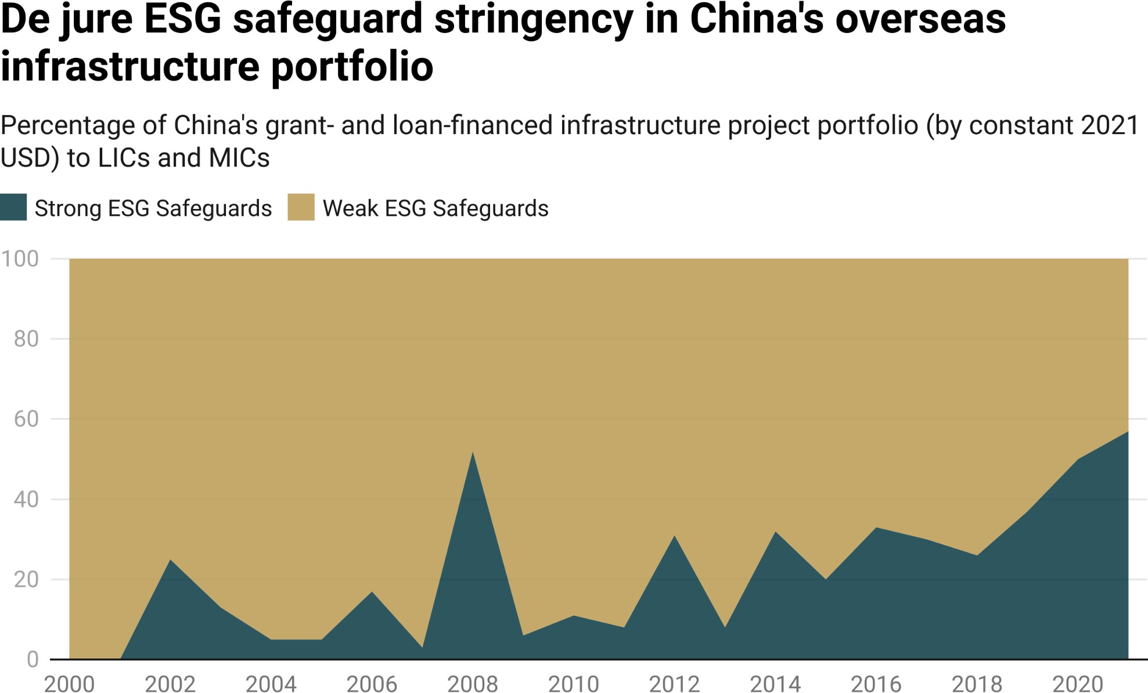

*Notes: The safeguard stringency ratings for each grant-giving and lending instrument are based on Table 3.1 and explained in Section A-9 of the Appendix.*

Figure 3.7 presents the estimated percentage of China’s grant- and loan-ﬁnanced infrastructure project portfolio in LIC and MICs with strong de jure environmental, social, and governance safeguards in place between 2000 and 2021. One can see a marked shift toward stronger ESG protections during the late BRI period (2018-2021). By the eighth full year of BRI project implementation (2021), approximately 57% of China’s grant- and loan-ﬁnanced infrastructure project portfolio in LIC and MICs had strong de jure environmental, social, and governance safeguards in place.[280] This represents a major departure from past practice: at the turn of the century, China’s entire grant- and loan-ﬁnanced infrastructure project portfolio in LIC and MICs had weak de jure environmental, social, and governance safeguards in place.

**Figure 3.8.1: Environment**

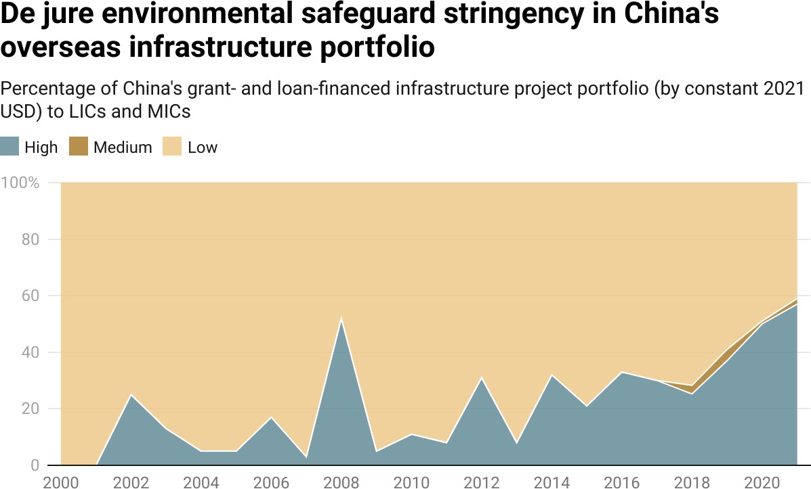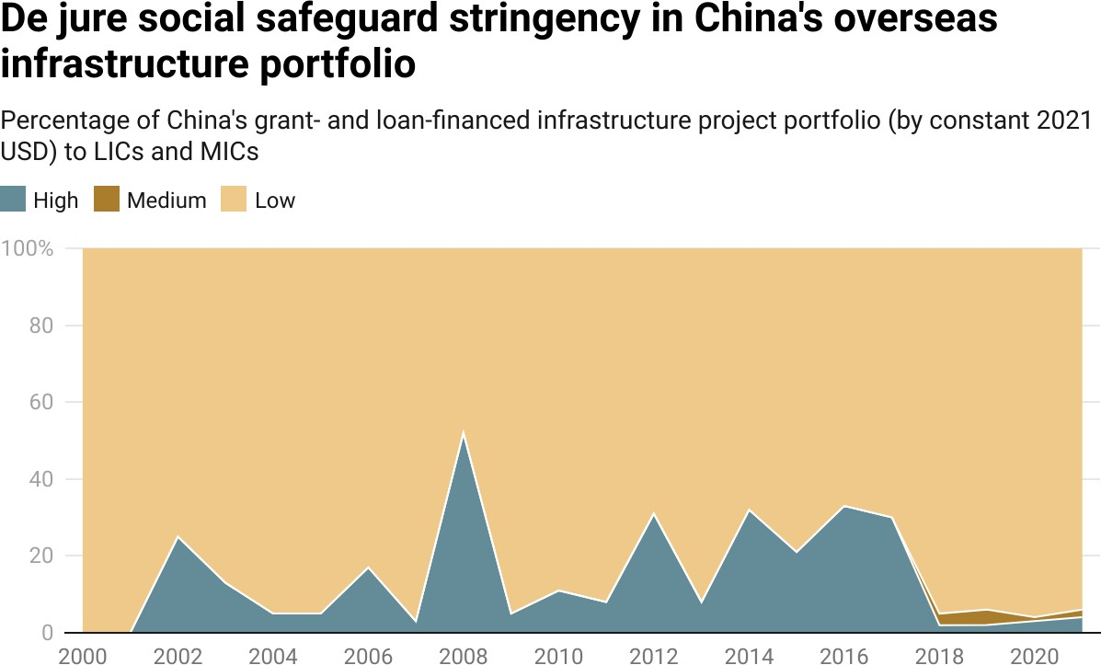

**Figure 3.8.2: Social**

**Figure 3.8.3: Governance**

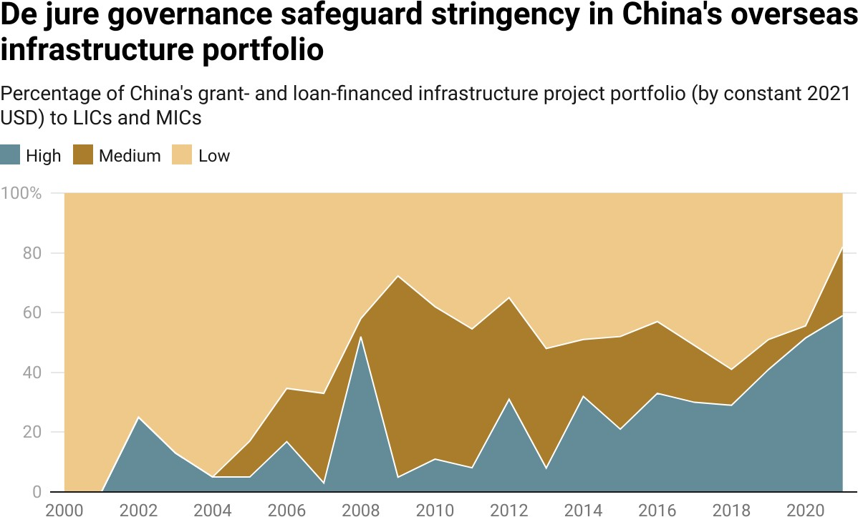

*Notes: The safeguard stringency ratings for each grant-giving and lending instrument are based on Table*

*3.1 and explained in Section A-9 of the Appendix.*

However, Beijing has not demonstrated comparable levels of enthusiasm for all types of ESG safeguards during the late BRI era. Figure 3.8 demonstrates that 37% of the infrastructure project portfolio was subjected to strong de jure environmental safeguards from 2018 to 2021, as compared to 20% during the previous eighteen-year period (2000-2017). Similarly, 40% of the infrastructure project portfolio was subjected to strong de jure governance safeguards from 2018 to 2021, as compared to 20% during the previous eighteen-year period (2000-2017).

Yet Beijing demonstrated far less interest in applying stringent social safeguards to its overseas infrastructure project portfolio during the late BRI era. Between 2018 and 2021, it shielded an increasing proportion of its grant- and loan-ﬁnanced infrastructure project portfolio from these types of safeguards (see Figure 3.8). While the proximate explanation for this change during the late BRI era was the removal of social safeguard enforcement mechanisms from the loan contracts of China’s state-owned commercial banks (see Table 3.1), the underlying reason why it took place is a mystery. One possibility—potentially deserving attention in future research—is that China’s aversion to strong de jure social safeguards is related to its own disconcerting experience with the World Bank’s social safeguards during the late 1990s and early 2000s (see Box 3a).[281]

##### Box 3a: China’s experience with the application of World Bank social safeguards to the Western Poverty Reduction Project in Qinghai

In 1997, the World Bank started working with China’s provincial government in Qinghai on the design of a $40-million loan for the Western Poverty Reduction Project. The purpose of the project was to resettle approximately 60,000 poor farmers to a new irrigation tract. The resettlement area was located in central Qinghai, more than 500 kilometers from the border of the Tibet Autonomous Region. However, in 1999, a transnational advocacy network—consisting of Tibet NGOs (including the Tibet Information Network and the International Campaign for Tibet) and multilateral development bank monitors (such as the Bank Information Center and the Center for International Environmental Law)—launched a campaign to prevent the World Bank’s Board of Directors from green-lighting the project. They claimed, with support from the U.S. Congress and U.S. Treasury, that approval of the project would be tantamount to bankrolling genocide (by diluting Tibet’s culture with 60,000 ethnic Chinese). They also claimed that the World Bank had failed to comply with its own social safeguards policy—by classifying a project as “Category B” when it should have been classiﬁed as “Category A.”[282]

When the Board of Directors voted to conditionally approve the project in June 1999, a group of campaigners hung a “World Bank Approves China’s Genocide in Tibet” banner outside World Bank headquarters. Robert Wade, who investigated claims about the project on behalf of the World Bank’s Inspection Panel, recounts that "[t]he NGOs put together a formidably effective campaign network. They established websites to share information and provide sample protest letters to the Bank which could be emailed directly from the site or printed out and faxed. The Tibet lobby sponsored rock concerts in cities around the world, with prepared postcards, fax machines and email facilities on hand. The result was a deluge of letters, postcards, emails and faxes the like of which the Bank had never seen, mainly from the U.S. and Europe. The Western media, both press and TV, lined up behind the critics. Reports in leading newspapers like The Financial Times, The New York Times and The Washington Post read as though taken straight from NGO handouts. They repeated the NGOs’ portrait of the project in the same language, often not distinguishing between what the NGOs claimed and what they, the journalists, reported as fact. Many reported as fact, for instance, that the move-in area was the birthplace of the Dalai Lama, which is simply false […]. Yet for all their claims to speak for Tibetans and for all

their denunciation of the consultation process, the NGOs never produced evidence that local people did not want the project beyond a few very brief and anonymous letters sent to the Tibet NGOs by people claiming to live near the move-in area” (Wade 2009: 32).

In July 2000, the World Bank’s Board of Directors convened to decide if it would approve the project. The discussions dragged on for multiple days, with developing country representatives advocating for project approval and certain developed country representatives calling for project cancellation. The issue was ultimately resolved when China’s Executive Director withdrew the project proposal from consideration. Beijing announced that the project would proceed with an alternative source of funding.

Of course, Beijing’s critics and rivals might question whether any of the “ﬁne print” in its overseas infrastructure ﬁnancing agreements even matters if ESG safeguards are not put into practice. To gauge whether China’s de facto application of ESG safeguards matches the de jure ESG safeguards in its ﬁnancing agreements, we leverage the detailed qualitative information that AidData has collected about how projects were designed and implemented in practice. The “cradle to grave” narratives in the 3.0 version of the GCDF dataset include detailed descriptions of efforts to mitigate ESG risks before, during, and after project implementation—for example, by adopting environmental management plans (EMPs) that respond to the ﬁndings and recommendations of an environmental impact assessment or by providing ﬁnancial compensation to project-affected persons (PAPs).

To make effective use of this qualitative information, we use a set of systematic search and categorization procedures (described in Section A-7 in the Appendix) to identify the subset of infrastructure projects for which there is evidence of efforts being undertaken by Chinese ﬁnanciers or implementing agencies to mitigate environmental, social, or governance risks before, during, or after project’s implementation. Between 2000 and 2021, we ﬁnd evidence that de facto ESG risk mitigation efforts were undertaken to support at least 210 infrastructure projects in 66 LICs and MICs supported by grants and loans from China.[283] The estimated cumulative value of China’s grant- and loan-ﬁnanced infrastructure project portfolio supported by de facto ESG risk mitigation efforts increased from $55 million in 2000 to $86 billion in 2021 (see Figure A48).

According to Figure 3.9, the percentage of Chinese grant- and loan-ﬁnanced infrastructure projects in the developing world supported by a de facto ESG risk mitigation effort steadily increased from 2% in 2000 to 18% in 2021, which is broadly consistent with China’s increasing use of strong de jure ESG safeguards over the same twenty-two year period.[284] However, Figure 3.9 also highlights an important shift that took place over time: although de jure and de facto risk mitigation efforts mostly moved in tandem during the pre-BRI era (2000-2013), the “delta” between de jure and de facto risk mitigation efforts widened during the BRI era (2014-2021).[285] By 2021, the gap between how Beijing applied ESG safeguards in principle and in practice was substantial: 57% of its infrastructure project portfolio in LICs and MICs beneﬁted from strong de jure ESG safeguards, yet there was evidence of de facto ESG risk mitigation efforts being undertaken in only 18% of the portfolio (see also Box 3b).[286]

**Figure 3.9**

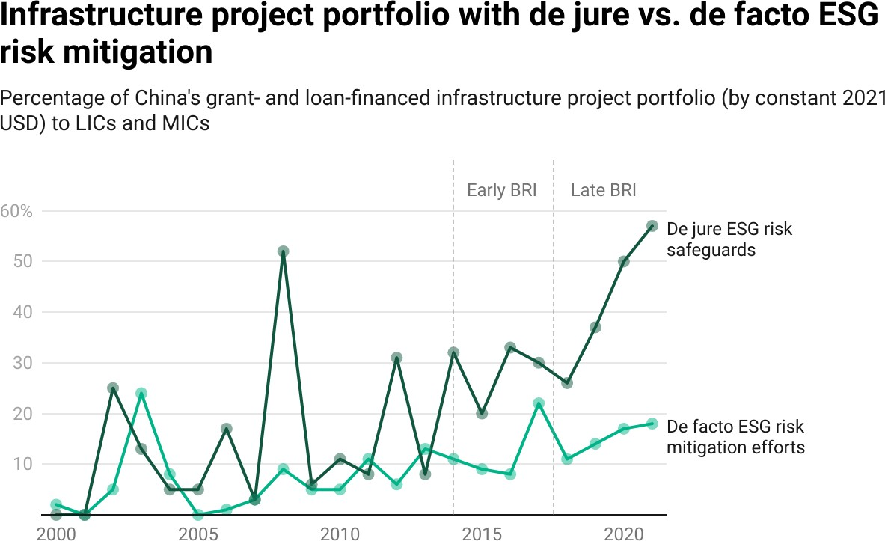

*Notes: De facto ESG risk mitigation efforts are measured using the methodology that is described in Section A-8. Strong de jure ESG safeguards are deﬁned in Section A-9 of the Appendix.*

(EIA), which was conducted by a local state-owned engineering services company (NESPAK) prior to commencement of construction in August 2015 (NESPAK 2015b).

NESPAK’s “comprehensive and complete” studies, which included the EIA and a 37-page environmental management plan (EMP), were deemed by third-party evaluators to be “compliant with international codes and standards” (NESPAK v. Mumtaz 2017). The EMP identiﬁed—and suggested corrective measures for—a series of risks related to land acquisition and resettlement, ﬂora and fauna, air quality and noise level, public utilities, seismic hazard, and the health and safety of workers (NESPAK 2015a). After recognizing that several heritage sites, as deﬁned by the Antiquities Act of 1975 (“Act”), would be affected by construction, NESPAK afﬁrmed the need “to avoid any interference with cultural heritage site(s) and public property as far as possible” (NESPAK 2015b). Noting that heightened noise levels could affect the structural integrity of cultural heritage sites, it called upon contractors to employ “noise barriers during construction” (NESPAK 2015a). Even though the Act prohibits construction activity within 200 feet of heritage sites, based on these plans, the Director General (DG) of Archeology issued a No Objection Certiﬁcate (NOC) in November 2015, “giving permission to carry on construction within prohibited limits of 200 feet of protected antiquities” (Mumtaz v. Punjab 2016).

*Lahore’s iconic 17th-century monument, Chauburji, was built by Mughal Emperor Shahjehan for his beloved daughter Jahanara Begum and served as an entrance to a royal garden, is shown here with the Orange Line in the background. It is one of 11 heritage sites affected by the project’s construction activities.*

***Photo Credit:*** *Anam Hussain/AlJazeera*

At the time, all environmental and social requirements under local laws appeared to have been met, giving CR-NORINCO and its local subcontractors the go-ahead to proceed with implementation. However, when construction crews began marking sites for demolition and earthworks in October 2015, it became apparent to local communities and civil society groups that “construction work [would] be carried out within 95 feet of Shalimar Gardens” and several other heritage sites (Ghani 2015). Almost immediately, a group of prominent environmental lawyers, urbanists, and rights advocates petitioned the Lahore High Court (LHC), arguing that the issuance of the NOC was “not only arbitrary, malaﬁde, patently illegal, without lawful authority but also without application of independent mind” (Mumtaz v. Punjab 2016). Before issuing the NOC, the DG of Archeology allegedly did not consider Pakistan’s commitments to international conventions for heritage conservation and was pressured by the government “to issue NOC within two days time without consulting any independent experts” (Mumtaz v. Punjab 2016).

After the government failed to provide satisfactory responses to these concerns, in January 2016, the LHC ordered an immediate suspension of project activities near 11 heritage sites. It also asked the authorities to report on their adherence to all de jure requirements related to land acquisition, noise levels, and solid waste management (Shaukat and Tanveer 2016). The court order threw the provincial government into a frenzy, as it anticipated long implementation delays that could prevent the project from reaching completion ahead of the July 2018 election. It immediately engaged experts to conduct separate Structural and Heritage Impact Assessments (SIA and HIA) and re-issued the NOC in July 2016—before the LHC issued its full verdict the following month. The matter was ﬁnally settled by the Supreme Court of Pakistan (SCP) when it rejected the government’s revised NOC on the same grounds, questioning the integrity of the government’s actions that clearly sought to remove this roadblock.

After several additional hearings and engagements with international experts to ascertain the true dangers from vibrations to the integrity of historic buildings, the SCP ﬁnally authorized the project’s resumption in December 2017 on the condition that its 31-item strong list of requirements would be implemented (NESPAK v. Mumtaz 2017). Within days, “Shehbaz speed” was on full display, as construction around these sites resumed after a delay of nearly two years.[288] Notwithstanding these efforts, the Sharif administration was unable to complete the project by the end of its term, ultimately allowing its chief political rivals from the Pakistan Movement for Justice party to cut the red ribbon in October 2020.

The saga of this project during the early BRI period demonstrates that even when strong de jure ESG safeguards are in place, the de facto implementation of such safeguards can falter or fail for a wide variety of reasons. In some cases, local ofﬁcials may be incentivized to prioritize speed over safety. In other cases, they may lack technical knowhow to enforce standards or may not fear penalties for non-compliance.

What then can we conclude based upon the available evidence? First, it is increasingly common for Chinese donors and lenders to include ESG safeguard provisions in their infrastructure ﬁnancing agreements with LICs and MICs. These provisions are broadly compatible with international ESG safeguards, such as the OECD Council Recommendation on Common Approaches for Ofﬁcially Supported Export Credits and Environmental and Social Due Diligence, the IFC’s Performance Standards on Environmental and Social Sustainability, the Uniform Framework for Preventing and Combating Fraud and Corruption, the OECD Council Recommendation on Bribery and Ofﬁcially Supported Export Credits, and the OECD Council Recommendation on Public Procurement. Second, many of these de jure provisions go far beyond identifying rules and standards related to ESG risk management; a rapidly expanding percentage of China’s overseas infrastructure project portfolio is underpinned by ﬁnancing agreements that include mechanisms for monitoring compliance and/or sanctioning noncompliance with those ESG rules and standards. Third, China’s de facto risk mitigation efforts are on the rise. Fourth, there is a growing gap between how ESG safeguards are applied to China’s overseas infrastructure projects in principle (de jure) and in practice (de facto), which is not unexpected given that ESG risk mitigation only recently became a priority for Beijing.

### Section 4: Do ESG safeguards produce a project performance payoff or penalty?

Given that Beijing has recently taken signiﬁcant measures to mitigate ESG risks in its overseas infrastructure project portfolio, an important question is whether these course corrections are compatible with the country’s reputation for speed and convenience. China did not become the Global South’s go-to banker for big-ticket infrastructure because of a happy accident. It earned the position by addressing a key source of unmet demand among LICs and MICs: ﬁnancing for infrastructure without overly complex and cumbersome ESG safeguard policies and procedures (Dollar 2016; Swedlund 2017; Parks 2019; Humphrey and Michaelowa 2019; Zeitz 2021; Horigoshi et al. 2022).[289]

In 2015, the G-24—a group of countries that work together to coordinate the positions of developing countries on international monetary and ﬁnancial issues—gave voice to the frustrations of LICs and MICs in a report entitled *Infrastructure Finance in the Developing World:*

"One aspect of the business practices of the World Bank and major [regional multilateral development banks] that has a particularly strong impact on infrastructure investment is environmental and social safeguard policies. Safeguards comprise procedures and restrictions on different types of lending operations meant to ‘safeguard’ the project from having negative impacts on the environment and social groups. Safeguards were ﬁrst instituted at the World Bank in the 1990s, and the other major [regional multilateral development banks] followed suit in subsequent years. The World Bank’s safeguards are still considered the most comprehensive and rigorous, but the safeguards of the AsDB, IADB, and AfDB have been gradually tightened over the years such that the differences between them are relatively small, particularly on the hot-button issues of environmental assessment and resettlement. As a project undergoes the initial screening process, MDB staff members determine whether it triggers any of the MDB’s applicable safeguards. Should that be the case, a separate series of special requirements must be followed before the loan can be approved and disbursed. The most frequently triggered safeguards in the case of the World Bank relate to environmental assessment and involuntary resettlement, and most frequently affect investment projects in the transportation, energy, and urban sectors. The required procedures are extraordinarily detailed and speciﬁc, and in many cases [...] extremely difﬁcult for borrowers and even staff to fully understand. Requirements often include time-consuming, lengthy studies to be undertaken by third-party experts (usually at the government’s cost), lengthy consultations with affected parties (sometimes including unelected non-governmental organizations), extensive mitigations measures, and lengthy mandatory prior public disclosure and comment periods during which time the project cannot move ahead. These requirements supersede whatever national laws may be in place in the borrowing country—a particularly troubling point of principle for many borrowing countries, beyond the practical impacts of safeguards” (Humphrey 2015).

China, which is a member of the G-24 and the World Bank’s largest borrower, appreciated these concerns (see Box 3a) and used them as a way to differentiate its offering to the global infrastructure ﬁnancing market. Under the banner of “South-South cooperation,” it emphasized its solidarity with the Global South and offered LICs and MICs an alternative model of development that prioritized the rapid installation of “hardware” over “software” investments that focus on policies and institutions.[290] Beijing’s message resonated—so much so that it became the developing world’s ﬁnancier of ﬁrst resort for highways, railroads, dams, bridges, seaports, airports, power plants, and electricity grids, while the MDBs downsized their infrastructure departments and programs due to a lack of borrower demand.[291] Several years ago, Chris Humphrey of ETH Zurich’s Center for Development Cooperation and Katharina Michaelowa of University of Zurich published interview evidence from three African countries on the changing nature of borrower demand for infrastructure ﬁnancing. They found that:

“[o]ne issue which ofﬁcials in all three countries noted as limiting their own demand for infrastructure lending from the World Bank and to a lesser degree the AfDB is the ‘hassle factor’ implicit in these types of projects from project design rules and environmental and social safeguards. Ofﬁcials from all governments concurred that the World Bank is particularly difﬁcult. ‘For hydroelectric and railroads, we don’t even talk to them, we just go straight to the Chinese,’ said an Ethiopian ofﬁcial. Discussing a major gas pipeline project, a Tanzanian ofﬁcial said, ‘The Chinese are a bit more expensive, but they are a lot easier and a lot faster for this kind of project. We didn’t even send a request to the World Bank for support, we went straight to the Chinese.’ Even in Malawi, with only small amounts of Chinese ﬁnance, ofﬁcials were experiencing these dynamics with a planned new coal-ﬁred power plant, to be funded by the Chinese at market-based interest rates. ‘The World Bank and AfDB wouldn’t fund it because the powerful shareholders would not agree to that kind of thing for environmental reasons. So we went with the Chinese.’” (Humphrey and Michaelowa 2019: 23)

In light of LIC and MIC demand for low levels of “hassle factor,” Beijing’s pivot toward a more stringent ESG safeguard regime raises the question of whether it will undermine the value proposition that it has traditionally used to differentiate itself from competitors in the global infrastructure ﬁnancing market. To better understand the implications of Chinese lenders and donors adopting stronger ESG safeguards, we use the 3.0 version of AidData’s GCDF dataset to compare the performance of Chinese government-ﬁnanced infrastructure projects with and without strong ESG safeguards. We do so with six outcome measures: (1) the percentage of projects that run behind schedule (2) the average length of commencement delays, (3) the average length of completion delays, (4) the average amount of time it takes to reach completion, (5) the frequency and value of project suspensions and cancellations, and (6) ESG risk prevalence rates.

We begin by comparing the percentage of China’s infrastructure project portfolio with and without strong de jure ESG safeguards that ran behind schedule. We classify a project as “behind schedule” if its actual implementation start date took place 3 months or more after its originally scheduled implementation start date, and/or if its actual completion date took place 3 months (or more) after its originally scheduled completion date. Figure A58 demonstrates that China’s grant- and loan-ﬁnanced infrastructure projects in LICs and MICs are equally as likely to run behind schedule when strong de jure ESG safeguards are in place as they are when strong ESG safeguards are not in place: 74% of infrastructure projects with strong de jure ESG safeguards ran behind schedule, and 75% without strong de jure ESG safeguards ran behind schedule.

Next, we examine the *average length* of commencement delays for China’s overseas infrastructure projects that are subject to ESG safeguards with varying levels of stringency. Figure A59 provides evidence that China’s overseas infrastructure projects encounter slightly shorter commencement delays when they are undertaken with strong ESG safeguards (47 days shorter, on average, than China’s overseas infrastructure projects without strong safeguards). The fact that infrastructure projects with strong ESG safeguards take slightly *less* time to launch than those without such protections is consistent with the old adage that “an ounce of prevention is worth a pound of cure.” It also implies that Beijing may be able to implement strong ESG safeguards without losing its competitive edge. As a general rule, MDB-ﬁnanced infrastructure projects with strong ESG safeguards face *substantially longer* commencement delays. Charles Kenny of the Center for Global Development estimates that ‘‘Category A’’ World Bank projects—environmentally and socially sensitive projects subjected to the organization’s most stringent safeguards—take 7.4 years (2,689 days), on average, to move from the proposal stage to the disbursement (project commencement) stage.[292]

The principle of “an ounce of prevention is worth a pound of cure” also evidently applies to completion delays in Chinese grant- and loan-ﬁnanced infrastructure projects. Figure A60 provides evidence that China’s overseas infrastructure projects face slightly shorter completion delays when strong ESG safeguards are in place (91 days less, on average, than China’s overseas infrastructure projects without strong ESG safeguards).[293] A separate, but closely related, insight from the 3.0 version of AidData’s GCDF dataset is that it takes an average of 3.2 years (1,163 days) to complete an infrastructure project without strong ESG safeguards, and it takes 8 fewer days (1,155 days) to complete an infrastructure project with strong ESG safeguards (see Figure A61).[294] These ﬁndings do not suggest that China’s reputation for speed is in jeopardy.

What then can we conclude about the “speed of implementation” differences between infrastructure projects with and without strong ESG safeguards? The most important point is that they are not large, which means that there is not much evidence to support the idea that ESG safeguards impose a signiﬁcant project performance penalty. The conventional wisdom is that ESG risk mitigation measures substantially impede infrastructure project implementation, thereby undermining a key component of the value proposition (speed) that China has traditionally used to differentiate itself from its competitors in the global infrastructure ﬁnancing market (Swedlund 2017; Parks 2019; Humphrey and Michaelowa 2019; Zeitz 2021). However, our ﬁndings do not support this argument. Quite the opposite: they suggest that China can reduce the ESG risk proﬁle of its overseas infrastructure portfolio if it is willing to accept slightly longer project implementation timelines (measured in dozens of days rather than hundreds or thousands of days).[295]

Another potential way that the performance of Beijing’s overseas infrastructure project portfolio might vary based on ESG safeguard stringency is the likelihood of project suspension or cancellation. The latest version of AidData’s GCDF dataset demonstrates that infrastructure projects with strong de jure ESG safeguards are substantially less vulnerable to suspension and cancellation after the ﬁnalization of a Chinese grant or loan agreement. According to Figure 3.10, while 74 Chinese grant- and loan-ﬁnanced infrastructure projects (worth $43 billion) with weak de jure ESG safeguards have been suspended or canceled since 2000, only 7 Chinese government grant- and loan-ﬁnanced infrastructure projects (worth $11 billion) with strong de jure ESG safeguards have been suspended or canceled since 2000.[296] These ﬁndings suggest that the application of more stringent ESG safeguards may help rather than hinder Beijing’s efforts to de-risk its overseas infrastructure project portfolio in the developing world.

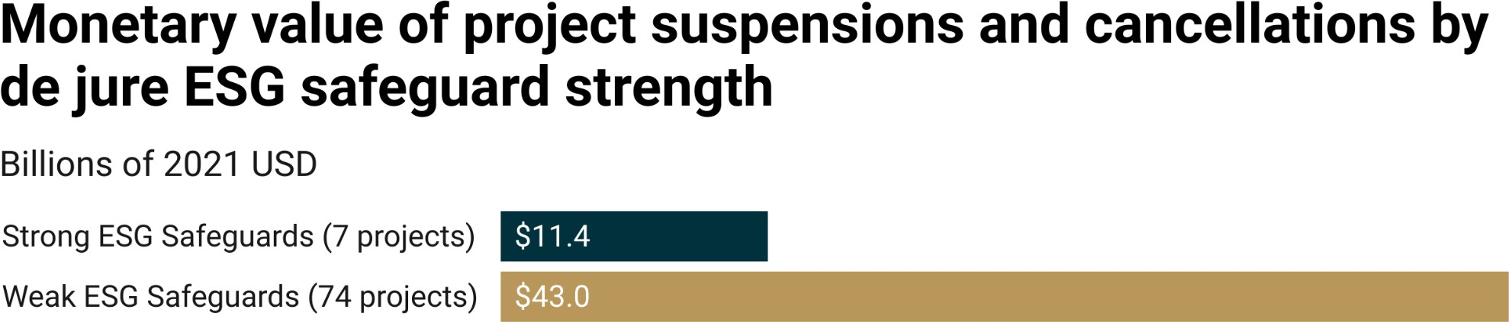

**Figure 3.10**

*Notes: Strong and weak de jure ESG safeguards are deﬁned in Section A-9 of the Appendix.*

Finally, we can use the 3.0 version of AidData’s GCDF dataset to determine whether ESG risk prevalence rates in China’s overseas infrastructure project portfolio vary according to ESG safeguard stringency. Figure 3.11 compares the percentage of China’s grant- and loan-ﬁnanced infrastructure project portfolio with signiﬁcant ESG risk exposure across two cohorts: projects with and without strong de jure ESG safeguards. Whereas 82% of projects that lacked strong de jure ESG safeguards faced signiﬁcant ESG risks, only 18% of projects with such safeguards encountered similar risks.[297] Figures A53, A54, and A55 in the Appendix demonstrate that these patterns are equally applicable to all three types (environmental, social, and governance) of ESG safeguards.

**Figure 3.10**

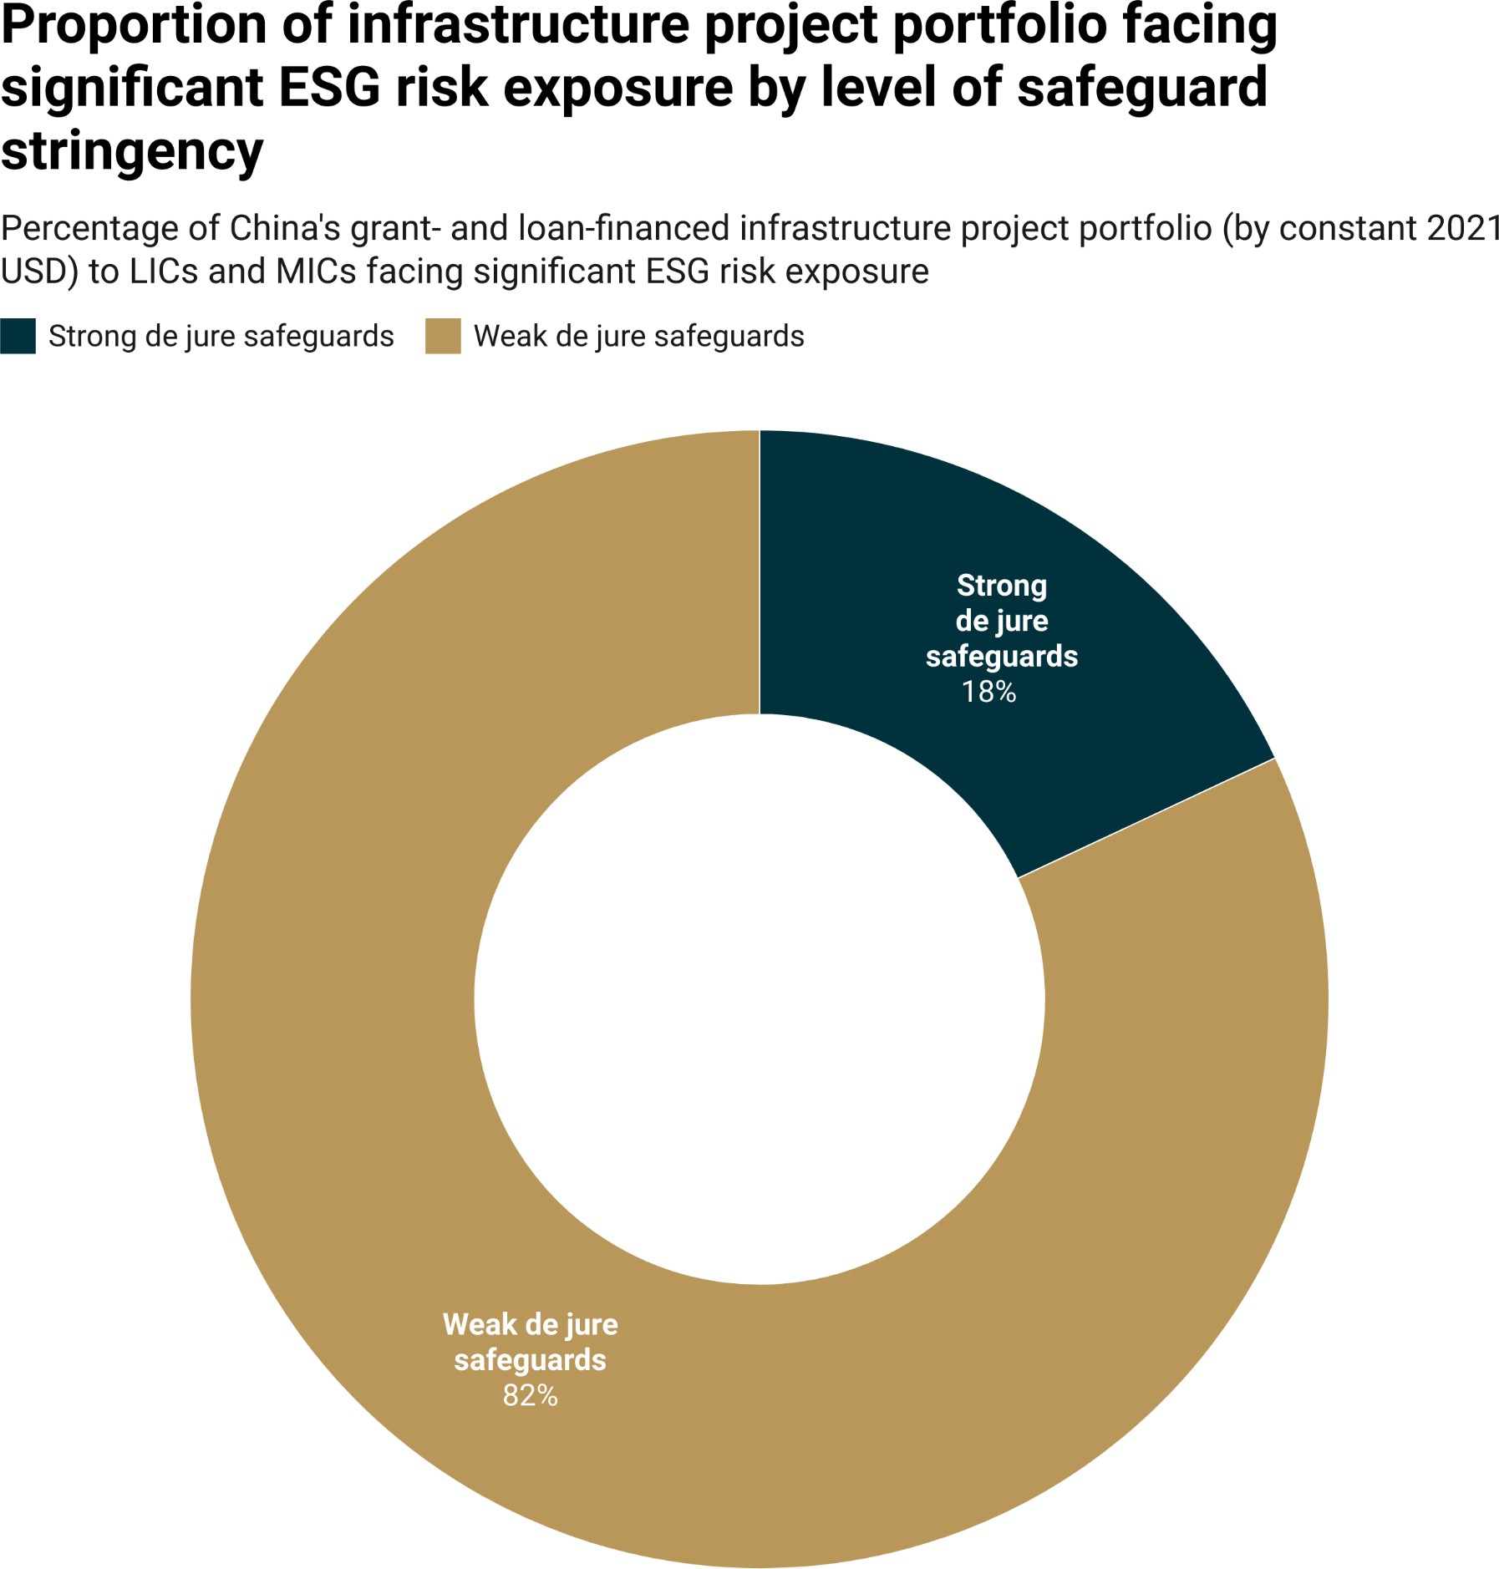

*Notes: Strong and weak de jure ESG safeguards are deﬁned in Section A-9 of the Appendix. The presence of signiﬁcant ESG risk exposure is based on a project-level composite measure that is described in Section 2 of Chapter 3.*

### Section 5: Decoding Beijing’s ESG risk mitigation strategy

In the remainder of this chapter, we will analyze the 3.0 version of AidData’s GCDF dataset to better understand how Beijing is seeking to manage and mitigate ESG risks in its infrastructure project portfolio. We see evidence of Chinese state-owned ﬁnanciers taking four ESG risk mitigation efforts to:

1. Defund the bilateral development ﬁnance institutions with the weakest safeguards
2. Support bilateral lenders and donors with the strongest safeguards
3. Outsource risk management via syndication and multilateralization
4. Unwind relationships with high-risk countries and double down on relationships with low-risk countries

#### Risk mitigation strategy #1: Defund the bilateral development ﬁnance institutions with the weakest safeguards

Most of Beijing’s ofﬁcial statements and publications about de-risking its overseas infrastructure project portfolio are anodyne and difﬁcult to interpret. The “Green Development Guidelines for Foreign Investment and Cooperation” that China’s Ministry of Commerce and Ministry of Ecology and Environment issued in July 2021 state that “[t]he greening of outbound investment and cooperation must be guided by Xi Jinping Thought on Socialism with Chinese Characteristics for a New Era. In the process, we must implement the spirit of the 19th CPC National Congress and the 2nd, 3rd, 4th and 5th Plenary Sessions of the 19th CPC Central Committee, Xi Jinping Thought on Ecological Civilization and the decisions of the CPC Central Committee and the State Council. We must stay committed to the new development concept, striving for the strong awareness of green development, efﬁcient use of resources, strict protection of the environment and effective control of carbon emissions. We should work to showcase China’s leadership in global endeavor toward green transition and our commitment to building the world into a better and cleaner place and laying the groundwork for a new development paradigm” (MOFCOM and MEE 2021).

However, when you cut through the ﬂowery rhetoric used by Chinese politicians and bureaucrats by following the money, a stark reality emerges: Beijing is entrusting a shrinking proportion of its overseas infrastructure project portfolio to the country’s policy banks (CDB and China Eximbank), which have particularly weak de jure ESG safeguards (see Table 3.1 and Table 3.2). Figure 3.12 plots two trends over time: the percentage of Chinese grant- and loan-ﬁnanced infrastructure projects with weak de jure ESG safeguards and the percentage of China’s infrastructure project portfolio ﬁnanced via bilateral loans from the country’s policy banks from 2000 to 2021. Beijing’s reliance upon policy bank ﬁnancing for infrastructure projects in LICs and MICs plummeted from 86% in 2013 to 41% in 2021.[298] The year-on-year changes that took place during this period also track very closely with year-on-year changes in the percentage of China’s overseas infrastructure project portfolio bankrolled by institutions with weak de jure ESG safeguards (see Figure 3.12).

**Figure 3.12**

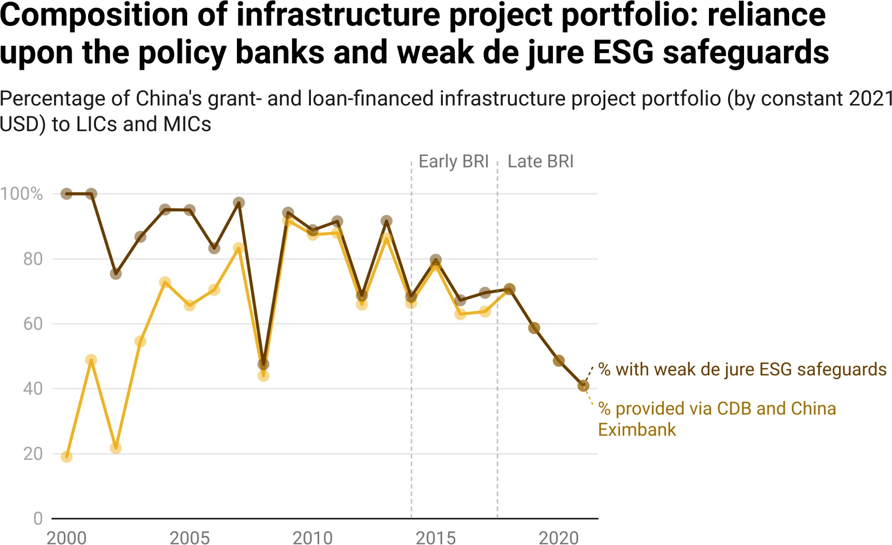

*Notes: Weak de jure ESG safeguards are deﬁned in Section A-9 of the Appendix.*

**Table 3.2**

## China’s grant- and loan-ﬁnanced infrastructure portfolio by type of ﬁnancing instrument over time

|  |  |  |  |
| --- | --- | --- | --- |
| **Contract Category** | **Pre-BRI**  **(2000-2013)** | **Early BRI**  **(2014-2017)** | **Late BRI**  **(2018-2021)** |
| Bilateral China Eximbank loan | 38.06% | 43.84% | 48.75% |
| Bilateral CDB loan | 39.79% | 23.93% | 11.61% |
| Bilateral MOFCOM loan or grant | 2.64% | 2.68% | 3.10% |
| Bilateral Chinese state-owned commercial bank loan | 5.14% | 9.38% | 8.84% |
| Syndicated loan with Chinese and multilateral bank participants | 0.80% | 2.17% | 1.45% |
| Syndicated loan with Chinese state-owned commercial banks and/or policy banks | 8.86% | 16.91% | 20.39% |
| PBOC/MOF grant or loan channeled through multilateral  institution | 0% | 0.12% | 0.89% |

|  |  |  |  |
| --- | --- | --- | --- |
| **Contract Category** | **Pre-BRI**  **(2000-2013)** | **Early BRI**  **(2014-2017)** | **Late BRI**  **(2018-2021)** |
| Supplier's credit from Chinese SOE | 4.71% | 0.77% | 4.97% |
| **Total** | **100%** | **100%** | **100%** |

*Notes: This table presents the shares of China’s grant- and loan-ﬁnanced infrastructure project portfolio (measured in constant 2021 USD) in LICs and MICs delivered via 8 ﬁnancial instrument categories across three different time periods: (1) the pre-BRI period from 2000 to 2013, (2) the early BRI period from 2014 to 2017, and (3) the late BRI period from 2018 to 2021.*

#### Risk mitigation strategy #2: Support bilateral lenders and donors with the strongest safeguards

Across the various bilateral instruments that Beijing has at its disposal to bankroll infrastructure projects in the developing world, CDB and China Eximbank loans offer the weakest de jure ESG safeguards. Rather than relying on these policy banks, Beijing is increasingly turning to a different set of ﬁnancial institutions—with lending and grant-giving instruments that include a more stringent set of de jure ESG safeguards—to ﬁnance infrastructure projects in LICs and MICs.

In Section 3 of Chapter 3, we discovered that bilateral loans from the country’s state-owned commercial banks, supplier’s credits from the country’s state-owned enterprises, and MOFCOM grants and interest-free loans have stronger de jure ESG safeguards than CDB and China Eximbank loans (see Table 2.1 in Chapter 2). This ﬁnding begs the question: has Beijing increased its use of these bilateral infrastructure ﬁnancing instruments? Table 3.2 above demonstrates that it has in fact done so, albeit in an incremental way: whereas the proportion of China’s infrastructure project portfolio in LICs and MICs ﬁnanced through these instruments amounted to 12.49% during the pre-BRI period (2000-2013) and 12.83% during the early BRI period (2014-2017), it jumped up to 16.91% during the late BRI period.

#### Risk mitigation strategy #3: Outsource risk management via syndication and multilateralization

Another strategy that Beijing could pursue to de-risk its overseas infrastructure project portfolio is outsourcing risk management to multilateral institutions, which are widely considered to be norm-setting, industry leaders in the design and implementation of ESG safeguards (Park 2010; Martin et al. 2015; Buntaine 2016; Brauneder et al. 2018; Buchanan et al. 2018; Narain et al. 2020, 2022).

One path to multilateralization is to directly entrust the management of grants and loans to an intergovernmental organization. For example, through its $2 billion trust fund at the African Development Bank (known as the Africa Growing Together Fund) and its $2 billion trust fund at the Inter-American Bank (known as the China Co-Financing Fund for Latin America and the Caribbean), the PBOC has fully delegated project design, preparation, implementation, and supervision responsibilities (including ESG safeguard application) to the multilateral institutions.

Another multilateralization option is to participate in syndicated loan agreements that are arranged by multilateral institutions. Many of these agreements have an A/B structure, whereby an MDB serves as the lender-of-record and keeps a part of the loan for its own account (the “A-loan”) while selling participation in the remainder of the loan (the “B-loan”). A common feature of A/B syndicated loan agreements with multilateral arrangers is that all B-loan participants yield authority to the A-loan provider for risk mitigation purposes (Esty and Megginson 2003; Bae and Goyal 2009; Hainz and Kleimer 2012; Broccolini et al. 2021; Lu et al. 2023a).

According to Table 3.2 above, Beijing has modestly increased its reliance upon multilateral institutions over time. The proportion of China’s infrastructure project portfolio in LICs and MICs ﬁnanced via syndicated loans with multilateral participants and PBOC/MOF loans and grants entrusted to multilateral institutions rose from 0.8% during the pre-BRI period (2000-2013) to 2.34% during the late BRI period (2018-2021). Despite the small size of this increase, it is noteworthy because PBOC and MOF grants and loans entrusted to multilateral institutions and syndicated loans with Chinese bank and multilateral institution participants have the most stringent ESG safeguards in our sample of infrastructure ﬁnancing agreements (see Table 3.1 in Section 3).

Syndicated loans with Chinese policy bank and state-owned commercial bank participants may be analogous to syndicated loans with multilateral participants if all members of the syndicate generally defer to the lending institution(s) with the strongest preference(s) for ESG risk mitigation. Consistent with this expectation, Table 3.1 above provides evidence that the ESG safeguards of state-owned commercial banks do indeed prevail over those of the policy banks in syndicated loan arrangements.[299]

Beijing has also intensiﬁed its use of these bilateral infrastructure ﬁnancing instruments over time. Figure 3.13 presents the percentage of Chinese grant- and loan-ﬁnanced infrastructure projects with strong de jure ESG safeguards in conjunction with the percentage of China’s infrastructure project portfolio ﬁnanced via syndicated loans with Chinese policy bank and state-owned commercial bank participants from 2000 to 2021. Beijing’s use of these types of syndicated loan arrangements for infrastructure projects in LICs and MICs has increased dramatically—from 0% in 2000 to 41% in 2021—and in tandem with the usage of strong de jure ESG safeguards.[300] The year-on-year changes that took place over this twenty-two year period track closely with year-on-year changes in the percentage of China’s overseas infrastructure project portfolio bankrolled by institutions with strong de jure ESG safeguards.

**Figure 3.13**

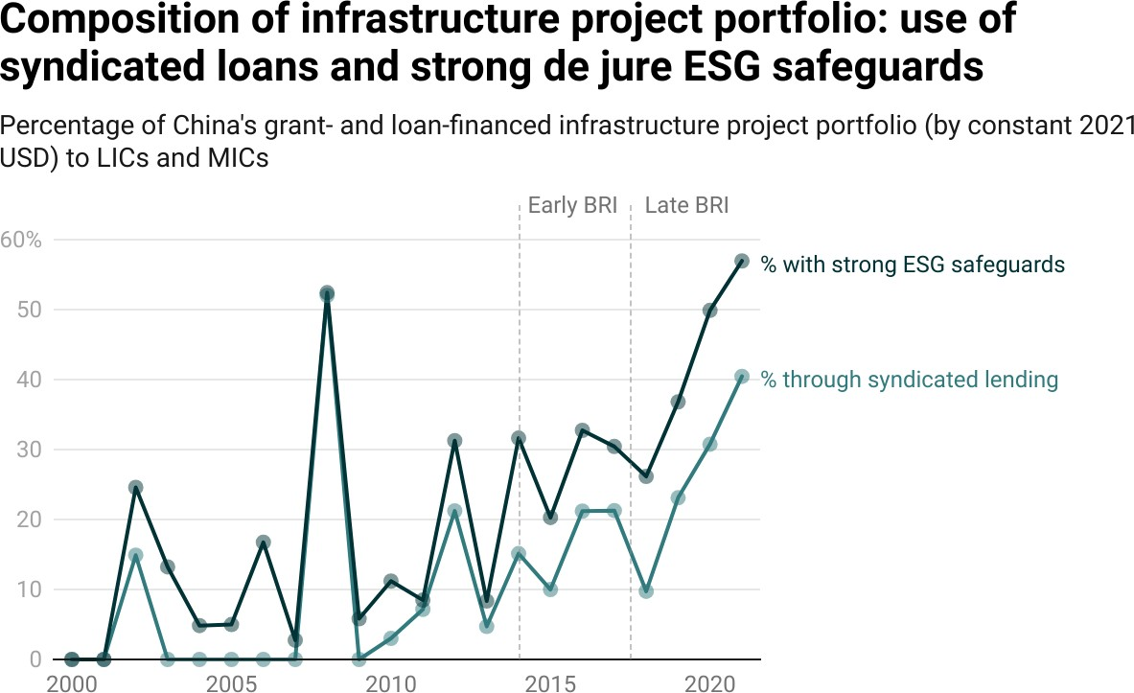

*Notes: Strong de jure ESG safeguards are deﬁned in Section A-9 of the Appendix.*

#### Risk mitigation strategy #4: Unwind relationships with high-risk countries and double down on relationships with low-risk countries

One additional way to reduce the ESG risk proﬁle of an infrastructure project portfolio is to use information about the past performance of host countries to guide future lending and grant-giving activities. That is to say, once a donor or lender has identiﬁed the subset of infrastructure projects in its portfolio that have presented signiﬁcant ESG risks, it may seek to identify where these projects are geographically concentrated so that it can identify host countries posing especially high levels of ESG risk and redirect funding for future infrastructure projects elsewhere. This reallocation—or “selectivity”—practice is followed by several major MDBs, including the Asian Development Bank and the World Bank (Buntaine 2011, 2015, 2016).

**Figure 3.14**

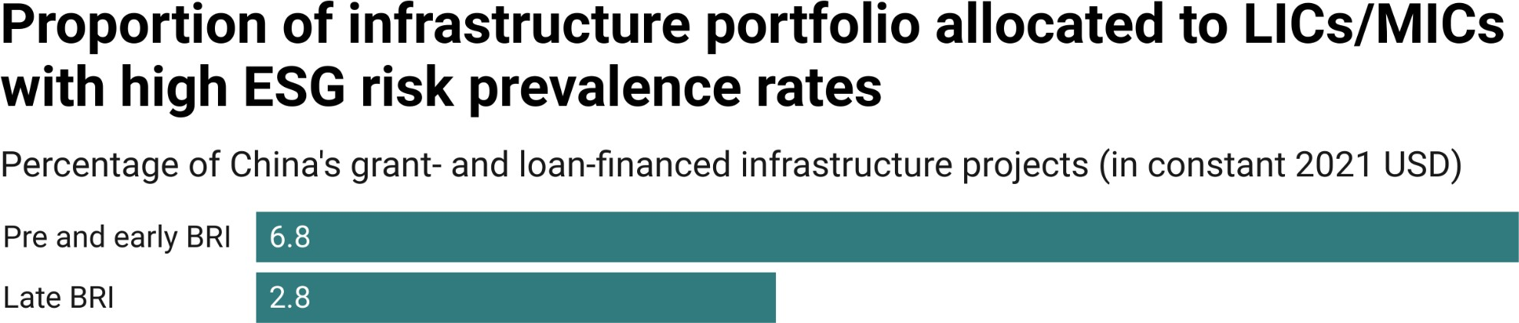

*Notes: This ﬁgure compares the overall percentage of China’s infrastructure ﬁnancing to LICs and MICs that was allocated to countries with high ESG risk prevalence rates in two time periods: (1) the pre-BRI and early BRI period (2000-2017) and (2) the late BRI period (2018-2021). Countries with a high ESG risk prevalence rate are deﬁned as those where at least 75% of China’s grant- and loan-ﬁnanced infrastructure project portfolio between 2000 and 2017 faced signiﬁcant ESG risks. The presence of signiﬁcant ESG risk exposure is based on a project-level composite measure that is described in Section 2 of Chapter 3.*

In order to gauge whether Beijing moved in this direction during the late BRI era, we ﬁrst create two cohorts of host countries: countries where at least 75% of China’s grant- and loan-ﬁnanced infrastructure project portfolio had signiﬁcant ESG risk exposure between 2000 and 2017 and countries where less than 75% of China’s grant- and loan-ﬁnanced infrastructure projects had signiﬁcant ESG risk exposure between 2000 and 2017. We then compare Beijing’s provision of infrastructure ﬁnancing to these two cohorts between 2018 and 2021. Figure

3.14 demonstrates that 2.8% of infrastructure ﬁnancing from Beijing during the late BRI era was directed to 9 LICs and MICs where at least 75% of China’s grant- and loan-ﬁnanced infrastructure project portfolio had signiﬁcant ESG risk exposure between 2000 and 2017. By way of comparison, Beijing allocated a substantially larger proportion (6.83%) of its grant- and loan-ﬁnanced infrastructure project portfolio to the same 9 countries between 2000 and 2017.

This pattern is consistent with the idea that Beijing has rebalanced the cross-country allocation of aid and credit to reduce the ESG risk proﬁle of its overseas infrastructure project portfolio.

Given that China has scaled back infrastructure spending in countries where its projects have faced particularly high levels of ESG risk exposure, another way that it could seek to recalibrate its portfolio is by ramping up support for infrastructure projects in countries where its projects have faced particularly low levels of ESG risk exposure. Figure 3.15 provides evidence that Beijing has in fact moved in this direction. More speciﬁcally, it demonstrates that during the late BRI period (2018-2021) 7.6% of infrastructure ﬁnancing from China was directed to 6 LICs and MICs where less than 10% of Chinese grant- and loan-ﬁnanced infrastructure projects had signiﬁcant ESG risk exposure between 2000 and 2017. This represented a signiﬁcant increase in late BRI era spending for low-risk countries, as Beijing allocated only 1.73% of its grant- and loan-ﬁnanced infrastructure project portfolio to the same 6 countries between 2000 and 2017.

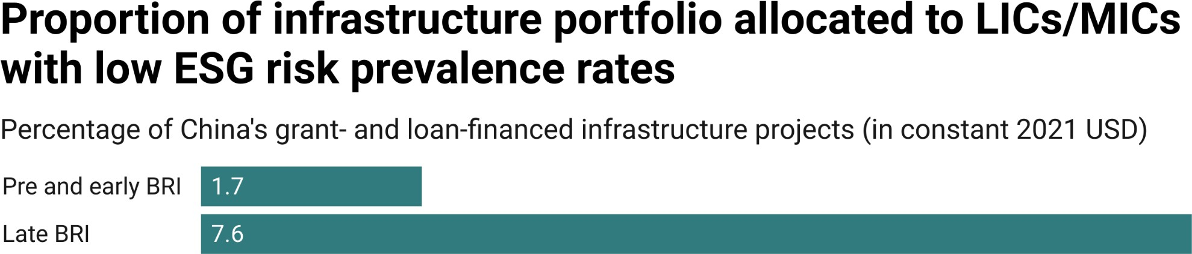

**Figure 3.15**

*Notes: This ﬁgure compares the overall percentage of China’s infrastructure ﬁnancing to LICs and MICs that was allocated to countries with low ESG risk prevalence rates in two time periods: (1) the pre-BRI and early BRI period (2000-2017) and (2) the late BRI period (2018-2021). Countries with a low ESG risk prevalence rate are deﬁned as those where less than 10% of China’s grant- and loan-ﬁnanced infrastructure project portfolio between 2000 and 2017 faced signiﬁcant ESG risks. The presence of signiﬁcant ESG risk exposure is based on a project-level composite measure that is described in Section 2 of Chapter 3.*

### Section 6: Is Beijing course-correcting or virtue-signaling?

When Beijing ﬁrst signaled interest in subjecting its overseas infrastructure project portfolio to more stringent ESG safeguards, critics and rivals were quick to question its sincerity. Jonathan E. Hillman of the Center for Strategic & International Studies (CSIS) penned an op-ed, in which he argued that China was engaged in a “greenwashing effort.” He wrote that “Xi knows that China is vulnerable on environmental issues. At a gathering of world leaders in Beijing last year, ‘green’ and ‘sustainable’ were the salt and pepper in his speech about the next phase of BRI. To address criticism, China unveiled no less than 11 new, green initiatives under BRI, all of which are voluntary, and none of which are binding or transparent” (Hillman 2020b). Kelly Sims Gallagher and Qi Qi of Tufts University wrote that “Chinese government rhetoric about greening the BRI is laudable, but it has yet to make any substantive changes toward that goal” (Sims Gallagher and Qi 2021). The U.S. and its allies also rejected the notion that Beijing’s overseas infrastructure projects had robust ESG protections in place. In November 2019, the U.S., Japan, and Australia announced that they were joining forces to establish a “Blue Dot Network” that would “evaluate and certify nominated infrastructure projects based upon adherence to commonly accepted principles and standards” and “promote market-driven, transparent, and ﬁnancially sustainable infrastructure development in the Indo-Paciﬁc region and around the world.” More recently, the U.S., the U.K., and the other members of the G7 have promoted a Partnership for Global Infrastructure and Investment (PGII)—previously known as the Build Back Better World (B3W) initiative—that they characterize as an alternative to the BRI and an option for countries that want to undertake infrastructure projects in strict accordance with internationally accepted ESG safeguards.[301]

However, this chapter demonstrates—with many new sources and types of evidence—that Beijing is not simply engaging in an international virtue-signaling exercise. It has taken meaningful steps to de-risk its overseas infrastructure project portfolio by ramping down the international lending activities of banks that lack strong ESG risk management guardrails, ramping up the provision of infrastructure ﬁnancing via institutions that have strong ESG safeguards in place, gradually unwinding aid and credit relationships with LICs and MICs that present high level of ESG risk, and redirecting new infrastructure ﬁnancing to lower-risk countries. At the same time, it is still at a relatively early stage in its journey from ESG skeptic to advocate and it will likely take many years—potentially even decades—to close the gap between the de jure and de facto application of ESG safeguards.[302]

We do not see evidence of Chinese development ﬁnance institutions uniformly complying with international ESG safeguards. Rather, we see evidence that some Chinese lenders and donors are gradually and selectively harmonizing their ESG safeguard policies and practices with those of traditional donors and lenders.[303] These changes should give pause to Beijing’s competitors in the global infrastructure ﬁnancing market. The G7 and some MDBs are currently trying to convince would-be partners in the developing world that (a) the BRI is a low-quality infrastructure option (privileging speed and convenience over safety and long-term sustainability) and (b) they can provide alternative, high-quality ﬁnancing options for countries that want to undertake infrastructure projects based on strict adherence to “international best practice” ESG safeguards.

However, this black-and-white branding strategy may lack resonance with its target audience, as LICs and MICs have already made it very clear that they have low levels of appetite for “gold standard” ESG safeguards. They want ﬁnancing partners that can quickly design and implement big-ticket, high-impact infrastructure projects without unreasonably high levels of ESG risk.[304] The evidence in this chapter suggests that Beijing may be better-positioned to answer this call than its competitors realize. It is now delivering large-scale infrastructure projects with increasingly robust ESG safeguards but without the lengthy implementation delays that often hobble similar projects backed by G7 members and MDB

# Annotation

216 At the same time, Beijing spurned nearly all invitations to follow the prevailing set of international development ﬁnance rules and norms, and it admonished Western donors and multilateral lenders for their “one-size-ﬁts-all” policies (Malik et al. 2021; Dreher et al. 2022).  
  
217 These ﬁgures only refer to active and completed projects. Between 2000 and 2021, Beijing also issued grants and loans worth $56 billion for 94 infrastructure projects in 49 LICs and MICs that were subsequently suspended or canceled.  
  
218 China was faster than its competitors at ﬁnalizing loan agreements for large-scale infrastructure projects. In 2008, Senegal’s then-President, Abdoulaye Wade, wrote in the Financial Times that “with direct aid, credit lines and reasonable contracts, China has helped African nations build infrastructure projects in record time. … I have found that a contract that would take ﬁve years to discuss, negotiate and sign with the World Bank takes three months when we have dealt with Chinese authorities” (Wade 2008).  
  
219 Between 2000 and 2021, Beijing ﬁnanced 735 infrastructure projects with grants and loans worth at least  
  
$250 million in 89 LICs and MICs, 377 infrastructure projects with grants and loans worth at least $500 million in 68 LICs and MICs, and 163 infrastructure projects with grants and loans worth at least $1 billion in 47 LICs and MICs. All of these ﬁgures include infrastructure projects that secured grant or loan commitments from China, which were subsequently suspended or canceled.  
  
220 With the 3.0 version of AidData’s GCDF dataset, we calculate the average amount of time needed to complete a Chinese grant- or loan-ﬁnanced infrastructure project by measuring the average number of calendar days between actual project implementation start dates and actual project completion dates. We only include active projects and completed projects that secured ofﬁcial commitments from China in our analysis.  
  
221 This ﬁnding implies that if a host country chose to accept three additional Chinese ODA or  
  
OOF-ﬁnanced development projects, it could reasonably expect to boost its economic (GDP) growth by  
  
2.85 percentage points within two years of Beijing agreeing to bankroll the projects. For more on the socioeconomic impacts of Chinese grant- and loan-ﬁnanced development projects, see Bluhm et al. (2020), Martorano et al. (2020), Dreher et al. (2022), Mandon and Woldemichael (2023), and Wellner et al. (forthcoming, 2023).  
  
222 More speciﬁcally, Dreher et al. (2021a) ﬁnd that one additional Chinese ODA- or OOF-ﬁnanced project increases economic growth by between 0.41 and 1.49 percentage points (pp) two years after the funding for the project is approved, on average. 0.95 pp represents the midpoint of this range.  
  
223 Bluhm et al. (2020) ﬁnd that, on average, Chinese ODA and OOF-ﬁnanced connective infrastructure projects reduce economic concentration (as measured by the Gini coefﬁcient of nighttime light output in all 9.3 km square grid cells within a particular subnational locality) by about 2.2 percentage points. They also provide evidence that these projects have effectively relocated economic output from dense areas like city centers to their immediate peripheries (i.e., peri-urban and suburban areas). The installation of connective infrastructure can accelerate spatially-inclusive economic development by making it easier for ﬁrms to reach more distant markets and individuals to commute or relocate to places of work. It also can also lower the cost of consumer goods and inputs, promote the development of new businesses, increase land values, boost agricultural production, and facilitate knowledge and technology spillovers.  
  
224 On the difﬁculty of implementing these types of projects on time and on budget, see Flyvbjerg et al. (2002).  
  
225 On this point, see Isaksson and Kotsadam (2018a, 2018b), Isaksson (2020), Dreher et al. (2019, 2022), Anaxagorou et al. (2020), Iacoella et al. (2021), and Baehr et al. (forthcoming).  
  
226 China’s demand-driven project selection system also encourages collusion between host country politicians and Chinese contractors. As Zhang and Smith (2017: 2335) explain, “Chinese ﬁrms and host governments enter into an informal alliance in which China’s companies persuade host governments to raise new aid projects with China while the contractors promise to help behind the scenes to secure ﬁnancing. The projects are reverse-engineered to suit the political needs of local politicians and the commercial strategies of Chinese contractors.” Similarly, Bräutigam (2019) argues that “[t]he Achilles Heel of China’s bank ﬁnancing model is that it relies heavily on Chinese companies to develop projects together with host country ofﬁcials. This creates strong incentives for kickbacks and inﬂated project costs. Particularly in election years, companies and public works ministers may collude to get projects approved.”  
  
227 Sole-source procurement is the rule rather than the exception in most of CDB and China Eximbank’s overseas loan agreements. In fact, these agreements almost always reference a speciﬁc commercial contract with a speciﬁc Chinese ﬁrm and strictly instruct the borrower to exclusively use the proceeds of the loan to ﬁnance the pre-selected commercial contract that is referenced in the loan agreement (Gelpern et al. 2021, 2022).  
  
228 This ﬁgure represents the cumulative percentage of China’s grant- and loan-ﬁnanced infrastructure project portfolio (measured in constant 2021 USD) between 2000 and 2017 with signiﬁcant environmental, social, or governance risk exposure. The average annual ESG risk prevalence rate, as deﬁned in Figure 3.2), was 47% between 2000 and 2017. Between 2000 and 2017, 1,403 infrastructure projects in LICs and MICs supported by grants and loans from China worth $383 billion (in constant 2021 USD) presented a signiﬁcant environmental, social, or governance risk (see Figure 1.13).  
  
229 Many of these problems probably could have been avoided via a variety of mechanisms: environmental and social impact assessments to ensure that indigenous peoples are granted free, prior, and informed consent (FPIC) and avoid siting projects near endangered habitats; competitive bidding rules to ensure good value-for-money; blacklisting procedures to avoid hiring contractors with a track record of participating in corrupt and collusive behavior; and grievance mechanisms to make it easier to identify and respond to the concerns of local stakeholders (Parks 2019; Dreher et al. 2022).  
  
230 In 2018, Beijing also ﬁnanced the creation of a China-IMF Capacity Development Center to train government ofﬁcials on debt sustainability frameworks (DSFs) in low-income countries and other BRI-related policy issues (Morris et al. 2020).  
  
231 In January 2021, Hu Huaibang, the former chairman of CDB, was sentenced to life in prison for taking  
  
$13 million in bribes. Then, in September 2021, He Xingxiang, a CDB vice president, was placed under investigation by China’s Central Commission for Discipline Inspection (CCDI) for “severe discipline and law violations” (Wilson 2022). One year later, Li Li, the former President of the Beijing Branch of the China Eximbank was expelled from the Chinese Communist Party due to corruption charges. Then, in March 2023, Liu Liange resigned from his position as chairman of Bank of China and CCDI investigated him on suspicions of corruption and graft (Wong and Zhai 2023).  
  
232 There is some evidence of international ﬁnancial institution (IFI) leaders trying to steer China in this direction (e.g., Kim 2017; Lagarde 2019).  
  
233 The MOU that established the MCDF can be accessed in its entirety via https://www.ndb.int/wp-content/uploads/2022/11/MCDF-MOU-for-disclosure.pdf.  
  
234 The MCDF, which is administered by the AIIB, describes itself as “a multilateral initiative to increase high-quality infrastructure and connectivity investments in developing countries in compliance with International Financial Institution (IFI) standards, including by encouraging other investors and ﬁnancial institutions to adopt such standards” (AIIB 2021).  
  
235 In September 2021, Xi Jinping announced at the UN General Assembly that China would no longer ﬁnance new coal-ﬁred power projects overseas. Then, in March 2022, NDRC, the Ministry of Foreign Affairs, the Ministry of Commerce, and the Ministry of Ecology and Environment published “Opinions on Jointly Promoting Green Development of the Belt and Road,” clarifying that China would “stop building new  
  
coal-ﬁred power projects abroad and prudently proceed with existing ones that are under construction” (National Development and Reform Commission, Ministry of Foreign Affairs, Ministry of Ecology and Environment, and Ministry of Commerce of the People’s Republic of China 2022).  
  
236 IPSF is a multilateral forum that aims to enable the exchange of practices and increase international cooperation on sustainable ﬁnance related matters. Its members include the EU, China, Singapore, Japan, and India.  
  
237 In February 2022, Yunnan Chen of the Overseas Development Institute (ODI) told Euromoney magazine that “China seems to have a more speciﬁc and targeted approach. Its ﬁnancial institutions are learning, recognising past mistakes and errors, and taking a more risk-averse approach to what projects they ﬁnance, and how they go about ﬁnancing and due diligence” (Wilson 2022).  
  
238 On this point, see Humphrey 2015; Dollar 2016; Swedlund 2017; Humphrey and Michaelowa 2019; Zeitz 2021; Horigoshi et al. 2022; and Blair et al. 2022b.  
  
239 Our analysis not only includes active and completed infrastructure projects, but also suspended and canceled projects. We include suspended and canceled projects to avoid sample selection bias, since such projects are more likely to present signiﬁcant ESG risks (Lu et al. 2023b).  
  
240 Martin et al. (2015); Brauneder et al. (2018); and UNEP-WCMC & IUCN (2023). The International Finance Corporation’s Performance Standard 6 (PS6) is widely used by international lenders and donors to identify “critical habitats,” which refer to areas of high biodiversity value (Narain et al. 2020, 2022).  
  
241 More speciﬁcally, we identify all Chinese grant- and loan-ﬁnanced infrastructure projects with locations that physically overlap with areas that were designated as terrestrial or marine protected areas or “likely” critical habitats (as deﬁned by PS6) at any point between 2000 and 2021. We exclude all projects without “precise” or “approximate” geocodes from the analysis. A project with “precise” geocodes is one for which have highly precise boundaries of the project’s geofeature(s). A project with “approximate” geocode is one identiﬁed within a 5 km radius of the precise boundaries of the project’s geofeature(s). As such, all projects geocoded to the ADM8, ADM7, ADM6, ADM5, ADM4, ADM3, ADM2, ADM1, and ADM0 levels are excluded.  
  
242 Environmentalists have expressed particular concerns about the siting of Chinese government-ﬁnanced infrastructure projects in geographical areas that may facilitate legal and illegal logging, agricultural frontier expansion, and human settlements in previously remote or pristine areas (Laurance et al. 2015; Yang et al. 2021; Baehr et al. 2022).  
  
243 Garnett et al. 2018.  
  
244 Free, prior, and informed consent (FPIC) refers to the right of Indigenous Peoples to provide or withhold consent, at any point, for development projects affecting their territories. It is a right granted to Indigenous Peoples in the UN Declaration on the Rights of Indigenous Peoples (UNDRIP) and it is based on the principle that “all peoples have the right to self-determination.” UNDRIP requires states to “consult and cooperate in good faith with the indigenous peoples concerned through their own representative institutions in order to obtain their free, prior and informed consent before adopting and implementing legislative or administrative measures that may affect them.”  
  
245 The decision to locate an infrastructure project within or outside the traditional territories of indigenous communities is only one way of understanding the social risk proﬁle of such a project. Consistent with the existing literature, we focus on this dimension of social risk because it can be consistently measured over geographic space and time for nearly all infrastructure projects (e.g., Yang et al. 2021).  
  
246 PLAD provides information on the birthplaces of 1,109 effective political leaders from 177 countries between 1989 and 2021 (Bomprezzi et al. 2023). Birthplaces are geocoded to the ADM2 (district) level. In order to identify projects that are vulnerable to political capture and manipulation, we identify all projects with locations in the home (birth) districts (ADM2s) of effective political leaders that secured Chinese grant or loan commitments during the periods of time when the leaders in question held ofﬁce.  
  
247 The World Bank uses ex ante, cost-beneﬁt analysis to screen candidate projects. It employs a simple project acceptability rule—“the expected present value of the project's net beneﬁts must be higher than or equal to the expected net present value of mutually exclusive project alternatives”—as “a safeguard against project choices being captured by narrow political or sectional interests” (Warner 2010: 2). By contrast, the Chinese grant-giving and lending institutions do not have analogous institutional safeguards in place (Dreher et al. 2019, 2022).  
  
248 An important caveat is that we only identify projects as being located within geographical areas that are vulnerable to political capture and manipulation if they fall within home districts (ADM2s) of political leaders. Therefore, projects that fall within the home regions (ADM1s), but not the home districts (ADM2s) of political leaders, are excluded. Nor do we consider the presence of non-infrastructure projects in the home districts (ADM2s) of political leaders.  
  
249 The “at least” qualiﬁer is important because of our inability to address “false negatives” that may affect our keyword-search based measures (see Section A-7 in the Appendix).  
  
250 We restricted our searches to infrastructure projects supported by grant and loan commitments worth  
  
$20 million (in constant 2021 USD) or more. Projects supported by larger ﬁnancial commitments generally have more detailed project descriptions, which provide a stronger basis for the identiﬁcation of environmental, social, and governance risks. They also present a lower risk of generating “false negatives.” 251 Chinese grant- and loan-ﬁnanced infrastructure projects can—and often do—face more than one type of ESG risk.  
  
252 A similar pattern is observable when one tracks the sheer number of Chinese grant- and loan-ﬁnanced infrastructure projects facing such risks. There is an apparent reduction in the number of infrastructure projects affected by ESG risk in 2020 and 2021 (see Figure A44), but given that the probability of ESG risks materializing and being detected increases as a project progresses from the ﬁnancial commitment phase to the implementation phase and the completion phase, we think the apparent reduction in 2020 and 2021 should be interpreted with caution.  
  
253 If the ESG risk prevalence rate is redeﬁned as the annual percentage of China’s grant- and loan-ﬁnanced infrastructure projects facing a signiﬁcant environmental, social, or governance risk, it rose from 25% in 2000 to 40% in 2013. It then fell to 36% (on average) during the early BRI period and 31% (on average) during the late BRI period (see Figure A44).  
  
254 In Figures 3.3, 3.4, and 3.5, we deﬁne the risk prevalence rate as the annual percentage of China’s grant- and loan-ﬁnanced infrastructure project portfolio (measured in constant 2021 USD) facing a given type of risk. In Figures A45, A46, and A47, we redeﬁne the risk prevalence rate as the annual percentage of China’s grant- and loan-ﬁnanced infrastructure projects facing a given type of risk.  
  
255 If the ESG risk prevalence rate is redeﬁned as the annual percentage of China’s grant- and loan-ﬁnanced infrastructure projects with signiﬁcant environmental, social, or governance risk exposure, the same pattern holds: the environmental risk prevalence rate is substantially higher (22%) than the social risk prevalence rate (14%) or the governance risk prevalence rate (7%).  
  
256 During the late BRI period, the total number of Chinese grant- and loan-ﬁnanced infrastructure projects with signiﬁcant environmental risk exposure, social risk exposure, and governance risk exposure also apparently declined (see Figures 3.3, 3.4, and 3.5).  
  
257 Given that the probability of ESG risk detection increases as an infrastructure project progresses from the ﬁnancial commitment phase to the implementation phase and the completion phase, still another possibility is that the apparent declines in ESG risk prevalence during the late BRI period reﬂect measurement imprecision.  
  
258 Table A10 demonstrates that environmental risk exposure was disproportionately concentrated in Central and Eastern Europe: whereas 13% of China’s grant- and loan-ﬁnanced infrastructure project portfolio (measured in constant 2021 USD) was located in the region between 2000 and 2021, 20.5% of its portfolio with signiﬁcant environmental risk exposure was concentrated in Central and Eastern Europe during the same 22-year period. By contrast, social risk exposure was disproportionately concentrated in Asia: whereas 36.4% of China’s grant- and loan-ﬁnanced infrastructure project portfolio (measured in constant 2021 USD) was located in the region between 2000 and 2021, 42.3% of its portfolio with signiﬁcant social risk exposure was concentrated in Asia during that 22-year period (see Table A10).  
  
259 According to Table A11, lower-middle income countries (LMICs) and low-income countries (LICs) received 26.8% and 25.3%, respectively, of China’s grant- and loan-ﬁnanced infrastructure project portfolio (measured in constant 2021 USD) during the 2000-2021 period. However, 35.8% of its portfolio with signiﬁcant social risk exposure was concentrated in LMICs—and 37.8% of its portfolio with signiﬁcant social risk exposure was concentrated in LICs—between 2000 and 2021.  
  
260 Only 15.8% of China’s grant- and loan-ﬁnanced infrastructure project portfolio (measured in constant 2021 USD) with signiﬁcant social risk exposure—and 25.6% with signiﬁcant environmental risk exposure—was located in UMICs (see Table A11).  
  
261 If a project falls across multiple grid cells, we assume the monetary value of the commitment for the project is evenly distributed within the project’s line or polygon. Thus, the total ﬁnancial commitment value for the project is split up among grid cells based upon the percentage of the project’s area that falls within each grid cell.  
  
262 In Figure A62, we replicate Figure 3.6 but scale the level of risk exposure in a given grid cell according to the cumulative count of Chinese grant- and loan-ﬁnanced infrastructure projects rather than the cumulative monetary value of Chinese grant and loan commitments for the same projects.  
  
263 The 3.0 version of the GCDF dataset provides stable URLs to hundreds of unredacted grant, loan, debt forgiveness, debt rescheduling, and escrow account agreements. AidData published a subset of these ﬁnancing agreements in March 2021 when the How China Lends report was ﬁrst published (Gelpern et al. 2021, 2022). However, the 3.0 dataset provides the full set of agreements retrieved by AidData.  
  
264 These 8 ﬁnancial instrument types were used by China to support 90.2% of its grant- and loan-ﬁnanced infrastructure project portfolio in LICs and MICs between 2000 and 2021. The remaining 9.8% of the portfolio consisted of projects supported by more “exotic” ﬁnancial instrument types (e.g., Engineering, Procurement, Construction and Financing (ECPDF) agreements). The 3.0 version of the GCDF dataset does not include many unredacted ﬁnancing agreements for these projects, so we exclude them from our analysis.  
  
265 Environmental and social safeguards are typically inapplicable to projects that do not involve the construction, rehabilitation, or expansion of infrastructure, although there are some exceptions to this general rule (most notably, projects that involve natural resource extraction without infrastructure components).  
  
266 The OECD Council Recommendation on Common Approaches for Ofﬁcially Supported Export Credits and Environmental and Social Due Diligence was previously known as the OECD Revised Council Recommendation on Common Approaches on the Environment and Ofﬁcially Supported Export Credits.  
  
267 For one of the eight ﬁnancial instrument categories (“syndicated loans issued by Chinese state-owned banks and multilateral institutions”), we were only able to identify two infrastructure project ﬁnancing agreements.  
  
268 For two of the eight ﬁnancial instrument categories (“supplier’s credits issued by Chinese state-owned companies” and “syndicated loans issued by China’s policy banks and state-owned commercial banks”), we relied on infrastructure ﬁnancing agreements that were issued in 2022 (in lieu of agreements issued between 2018 and 2021) to ensure adequate coverage during the late BRI period (see Tables A5, A6, and A7 in the Appendix for more details).  
  
269 The agreement-level ratings that are reported in Table A8 demonstrate that most of the observed heterogeneity in ESG safeguard stringency is across ﬁnancial instrument types rather than across agreements within a given ﬁnancial instrument type. See also Tables A6 and A7.  
  
270 Our coding sample underrepresents China’s infrastructure ﬁnancing to some regions and income brackets and overrepresents its infrastructure ﬁnancing to other regions and income brackets (see Section A-10). The external validity of our sample would be a concern if China’s infrastructure ﬁnancing agreements varied systematically by region or income bracket. However, we do not ﬁnd much evidence that China’s infrastructure ﬁnancing agreements differ signiﬁcantly by region or income bracket (see Table A4 in the Appendix).  
  
271 Beyond the fact that some Chinese ﬁnanciers have published environmental policies and standards on their websites and others have not, Narain et al. (2020) does not document any safeguard variation across Chinese state-owned creditors that ﬁnance overseas infrastructure projects. However, Narain et al. (2020) does not systematically evaluate the safeguard provisions contained in the ﬁnancing agreements of Chinese state-owned creditors. Nor does the study capture any of the changes that took place during the late BRI period (2018-2021).  
  
272 The “High,” “Medium,” and “Low” designations are not comprehensive measurements of ESG safeguard stringency vis-à-vis international standards, such as PS6. They only provide measurements of whether ESG rules and standards exist and whether there are mechanisms in place for monitoring compliance or sanctioning noncompliance. A potentially productive avenue for future research would be to construct “distance-to-frontier” safeguard stringency measures that are based on PS6 or an analogous set of international standards that are broadly encompassing.  
  
273 China Eximbank’s infrastructure loan agreements received low environmental, social, and governance safeguard ratings. CDB’s infrastructure loan agreements received low environmental and social safeguard ratings, but a medium governance safeguard rating—due to the fact that two out of the three CDB contracts in the coding sample included anti-corruption and anti-money laundering requirements as well as requirements to prepare and submit ﬁnancial statements in accordance with International Financial Reporting Standards (IFRS) or the Generally Accepted Accounting Principles (GAAP) of the Financial Accounting Standards Board (FASB).  
  
274 These ﬁndings are consistent with those of Narain et al. (2020, 2022).  
  
275 The apparent beneﬁt of including a multilateral institution or a state-owned commercial bank in a lending syndicate is that it can lead every other member of the syndicate to adopt their (stronger) safeguards.  
  
276 Although the environmental and governance safeguards that apply to supplier’s credits strengthened during the late BRI period, the social safeguards that apply to supplier’s credits did not.  
  
277 Table 3.1 provides evidence that China’s state-owned commercial banks weakened the social safeguards that apply to their bilateral loans and their syndicated loans during the late BRI period.  
  
278 In the sample of ﬁnancing agreements that we evaluated, social laws and standards were given expansive deﬁnitions, including (a) laws, rules, and regulations in borrower countries related to work, social security, industrial relations, occupational health and safety, public participation, property ownership (formal and traditional), and the protection and empowerment of indigenous peoples and ethnic groups; the projection, restoration, and promotion of cultural heritage and archaeological artifacts; and the resettlement or economic displacement of persons; (b) the OECD Revised Council Recommendation on Common Approaches on the Environment and Ofﬁcially Supported Export Credits; (c) the Equator Principles; (d) UN treaties and conventions on human rights; and (e) international labor agreements.  
  
279 To map individual grants and loans for infrastructure projects to our taxonomy of infrastructure ﬁnancing instruments (consisting of 8 loan and grant-giving instruments), we use a combination of the funding agency, implementing agency, co-ﬁnancing agency, receiving agency, number of lenders, ﬂow type, and supplier’s credits ﬁelds in the 3.0 version of the GCDF dataset. These 8 ﬁnancial instrument types cover 90.2% of China’s grant- and loan-ﬁnanced infrastructure project portfolio in LICs and MICs between 2000 and 2021. We do not assign de jure ESG safeguard stringency ratings to the remaining 9.8% of the portfolio, which represents infrastructure projects ﬁnanced with other types of ﬁnancial instruments. As such, whenever we report portfolio-level summary statistics related to the application of de jure ESG safeguards, we disregard projects for which de jure ESG safeguard stringency ratings could not be reliably assigned (i.e., 9.8% of the LIC and MIC portfolio).  
  
280 Table A12 provides country-level summary statistics on the percentage of China’s grant- and  
  
loan-ﬁnanced infrastructure project portfolio with strong de jure ESG safeguards between 2000 and 2021.  
  
281 It is, however, worth noting that there was never much support in Beijing for strong social safeguards across our entire 22-year period of study (2000-2021).  
  
282 Category A projects pose the most severe environmental and social risks; they often involve large-scale infrastructure, industrial-scale chemical manufacturing, or natural resource extraction activities. The World Bank subjects these projects to its most stringent ESG safeguards, but it also acknowledges that the risks these projects pose can be difﬁcult or impossible to fully mitigate. Category B projects also pose signiﬁcant environmental and social risks, but the World Bank expects that it can reasonably and readily mitigate all or most of these risks during implementation (Buchanan et al. 2018).  
  
283 The “at least” qualiﬁer is important because of our inability to address “false negatives” that may affect our keyword-search based measures (see Section A-7 in the Appendix).  
  
284 In the Appendix, we present a different version of this graph (Figure A50) that measures the annual percentage of China’s grant- and loan-ﬁnanced infrastructure projects in LICs and MICs supported by (a) one or more de facto ESG risk mitigation efforts and (b) strong de jure ESG safeguards. It too shows that Beijing’s de jure risk mitigation efforts generally outpaced its de facto risk mitigation efforts.  
  
285 Figure 3.9 treats an infrastructure project’s ﬁnancial commitment year as the year in which ESG risk mitigation efforts were undertaken. However, given that the probability of ESG risk mitigation measures being undertaken and detected increases as a project progresses from the ﬁnancial commitment phase to the implementation phase (and the completion phase), it may also be useful to treat an infrastructure project’s commencement (implementation start) year or its completion (implementation end) year as the year in which ESG risk mitigation efforts were undertaken. We do so in Figures A51 and Figure A52.  
  
However, these two ﬁgures do not show substantially smaller (or larger) gaps between de jure and de facto ESG risk mitigation efforts. In Figure A51, the average annual percentage point difference between infrastructure projects with strong de jure ESG safeguards and infrastructure projects that involved de facto ESG risk mitigation efforts based on the completion year is 10%. In Figure A52, it is 13.2% based on the commencement year. In Figure 3.9, it is 12%.  
  
286 An important caveat is that our measure of whether any effort was undertaken to mitigate ESG risks before, during, or after project’s implementation almost certainly underestimates the true level of risk mitigation effort (due to the previously-mentioned “false negative” challenge).  
  
287 For more details, see Project ID#54420, 53820, 37280 in the 3.0 version of AidData’s GCDF dataset.  
  
288 Lahore is the capital of the Punjab province and the political power base of the then-incumbent Pakistan Muslim League party. Its leadership, including then-Prime Minister Nawaz Sharif and his younger brother, Punjab Chief Minister Shehbaz Sharif, belong to the city’s business elite. Since ﬁrst coming to power in the mid-1980s, the Sharifs’ political strategy has hinged on ﬂagship infrastructure projects, such as major new international airports and inter-city motorways. During his ﬁrst tenure in ofﬁce after returning from exile in 2008, the younger Sharif delivered the Lahore Bus Rapid Transit (BRT) at “Shehbaz speed” within 10 months (Majid et al. 2018; Express Tribune 2016). His party was rewarded with a resounding electoral victory in the 2013 elections, which it attributed to the BRT.  
  
289 According to David Dollar, who served as the World Bank’s country director for China (2004-2009) and the U.S. Treasury Department’s economic and ﬁnancial emissary to China (2009-2013), “[the] procedures developed by the World Bank are the gold standard of environmental and social safeguards in infrastructure projects. However, they have had a number of unintended consequences. It has become time-consuming and expensive to do infrastructure projects with the World Bank, and as a result, developing countries have turned to other sources of funding. [...] Given this situation, the emergence of China as a major funder of [...] infrastructure projects has been welcomed by most developing countries.  
  
China is seen as more ﬂexible and less bureaucratic. It completes infrastructure projects relatively quickly so that the beneﬁts are seen sooner” (Dollar 2016).  
  
290 At the Belt and Road Forum for International Cooperation in 2017, Xi Jinping described the BRI as “a new option for other countries and nations who want to speed up their development while preserving their independence” (Belt and Road Forum for International Cooperation 2017, emphasis added).  
  
291 In 2010, the World Bank’s Independent Evaluation Group found that “[t]wo thirds of [World Bank] managers interviewed reported that some clients had avoided or were dropping a [World] Bank project because of safeguard policies” (IEG 2010: 73).  
  
292 The ﬁndings reported in Kenny (2023) are speciﬁc to the 2010-2017 time period. In 2010, a study by the World Bank’s Independent Evaluation Group (IEG) also revealed that the average cost of safeguards for a Category A project at the World Bank is $19 million (IEG 2010).  
  
293 These ﬁndings are likely related to the ﬁndings on commencement delays. ESG safeguards often require that contractors and their host country counterparts take a series of time-consuming actions—such as conducting environmental impact assessments (EIAs) and preparing resettlement action plans  
  
(RAPs)—during the pre-implementation phase of a project, which can eliminate implementation obstacles that would otherwise delay completion.  
  
294 By way of comparison, it takes World Bank and Asian Development Bank projects, on average, 6 years to move from the commencement stage to the completion stage (see Bulman et al. 2017: 362).  
  
295 This ﬁnding is relevant to the loan repayment challenges that we document in Chapter 2 because the speed of implementation can affect a project’s revenue generation potential and thus a borrower’s ability to meet its loan repayment obligations. The CDB-ﬁnanced Jakarta-Bandung High-Speed Railway Construction Project, which is running over-budget and behind schedule, is a case in point. Since it was ﬁnanced through a limited recourse project ﬁnance transaction and the railway is not yet in operation, the borrower is unable to make debt service payments via railway revenues (Malik and Parks 2021; Kuo 2021).  
  
296 Our ﬁndings are consistent with those of Lu et al. (2023b). They ﬁnd that Chinese-ﬁnanced power plant projects posing higher levels of environmental risk are more likely to be suspended.  
  
297 Figure A49 tracks the same two cohorts over time. Notwithstanding a sharp increase in the percentage of the infrastructure project portfolio subjected to strong de jure ESG safeguards during the late BRI period, it shows that the same empirical pattern is generally consistent across the 2000-2021 period.  
  
298 This 45 percentage point decline obscures some differences across the two policy banks. Whereas the percentage of China’s infrastructure project portfolio in LICs and MICs ﬁnanced via CDB declined from 39.79% in the pre-BRI period (2000-2013) to 11.61% during the late BRI period (2018-2021), the percentage ﬁnanced via China Eximbank actually increased from 38.06% to 48.75% across these two periods (see Table 3.2). However, upon closer inspection, one can see that the percentages of China’s infrastructure project portfolio in LICs and MICs ﬁnanced via CDB and China Eximbank declined (for the most part) over the course of the late BRI period. Figures A56 and A57 demonstrate that the percentage of the portfolio ﬁnanced via China Eximbank fell from 58.7% in 2018 to 18.3% in 2021 and the percentage of the portfolio ﬁnanced via CDB fell from 11.9% in 2018 to 4.3% in 2020 before ticking back up to 22.5% in 2021.  
  
299 Suﬁ (2007) demonstrates that lead arrangers reduce the costs of due diligence for all other syndicate participants.  
  
300 According to Table 3.2 above, the percentage of China’s infrastructure project portfolio in LICs and MICs ﬁnanced via syndicated loans involving state-owned policy banks and commercial banks increased from 8.86% during the pre-BRI period (2000-2013) to 16.91% during the early BRI period (2014-2017) and 20.39% during the late BRI period (2018-2021).  
  
301 In September 2023, the U.S., France, Germany, Italy, the EU, India, the UAE, and Saudi Arabia also announced plans to develop an India-Middle East-Europe Economic Corridor (IMEC).  
  
302 It is also important to keep in mind that, as of 2021, 40% of Chinese infrastructure ﬁnancing to LICs and MICs was still being channeled via bilateral CDB and China Eximbank grants and loans. This is signiﬁcant, since this chapter provides evidence that CDB and China Eximbank have for the most part not reformed/modernized their de jure ESG safeguards in a way that is comparable to the practices of multilateral institutions, state-owned commercial banks, or the lead arrangers of syndicated loans.  
  
303 There are reasons to believe that this approach of gradual and selective harmonization will be a longer-term process. On July 16, 2021, China’s Ministry of Commerce and the Ministry of Ecology and Environment issued “Green Development Guidelines for Overseas Investment and Cooperation,” which recommend that project sponsors and contractors comply with international standards or Chinese standards when the laws and regulations of host countries are vague or weak.  
  
304 On this point, see Humphrey 2015; Dollar 2016; Swedlund 2017; Humphrey and Michaelowa 2019; and  
  
Zeitz 2021.